# Report and Manual for

# LoCaGas LCA-Decision Tool

Table of Content

Report and Manual for 1

LoCaGas LCA-Decision Tool 1

1. Introduction: 2

2. Concept of the tool: 3

3. Model structure 6

Dual Fuel Engine (DFE): 6

Oxygen Enrichment Combustion (OEC): 15

Spinning Fluids Reactor (SFR) 23

4. Assumptions 35

5. Technological implementation of the Web App 37

LCA Concept 38

Next steps: 42

# 1. Introduction:

This document is an informal report about the LCA-Decision which is developed from the University of Rostock in context of the LoCaGas project. The Report is written for the internal use in the LoCaGas project. It is not meant to be publicised.

Thedevelopment of the LCA decision tool is part of the Work Package 4 and included in activity 4.5. The aim is to “Develop a an LCA-based tool for landfilling operators”.

As a foundation for the tool the activity 4.3: “Development of sustainability criteria & defining scope of LCA study” was prepared.

The LCA-based decision tool was developed as an web-application. It compares the three project technologies “Dual Fuel Engine”, “Oxygen Enrichment Combustion” and “Spinning “Fluid Reactor” as well as a baseline scenario called “Flare” on an ecological and economic level.

The ecological comparison is based on a LCA approach. The results are calculated based on the ReCiPe 2016 hierarchy model and presented in 18 midpoint impact categories.

For the economic results the Net Present Value (NPV) is calculated and presented.

At the current development status the concept and calculation logic is finished and the background data frames are prepared. The tool is ready to be used. At the same time the data frames are filled with exemplary data. The preparation of the background LCA values and the values of the different project technologies have to be calculated, collected and filled into the data frames.

On the following pages the tool concept, calculation logic and LCA approach will be presented.

# 2. Concept of the tool:

The tool is based on the following basic concept. There are background data frames for every technology. In the data frames the characteristics of each technology are defined. These characteristics include the following central key points for each technology:

1. Technology limitations and technology resource requirements for different technology sizes
2. Load dependent resource requirements. This includes how much oil, coolant, maintenance etc. the technology requires at different loads.
3. Load dependent emissions. This includes data on the quantity of different emission types at different loads (for SFR emissions are excluded)
4. Life stage impacts. This includes the LCA results for a defined amount of required resource. For example 1L of oil or 1L of coolant.

Besides the technology specific background data, general data frames were defined for further calculations. These include:

1. Economic data. This includes prices for different operating resources and technologies.
2. Country specific data. This includes country specific parameters, like service prices, energy prices, tax amount and others.
3. Energy data. This includes country specific data on the environmental impacts of a predefined amount of energy in the project countries.
4. Emission impacts. This includes data on the environmental impact of a predefined amount of the specific emissions. For example 1kg of Carbon Monoxide.

The tool calculations are based on this background data and combine it with the Input parameters. These input parameters include the following:

1. Gas specific input parameters:
   1. Initial gas volume [m^3/h in year 1]
   2. Initial methane content [% in year 1]
   3. Time horizon [years]
   4. K-value
2. Economic parameters:
   1. Project country
   2. Electrical Energy Price [€/kWh el.]
   3. Thermal Energy Price [€/kWh th.]
   4. Depreciation period [years]
   5. Tax rate [%]
   6. Discount rate [%]
3. Additional Parameters:
   1. Energy source
   2. Annual machine operating time
   3. Type of additional fuel for DFE
   4. CHP plant available

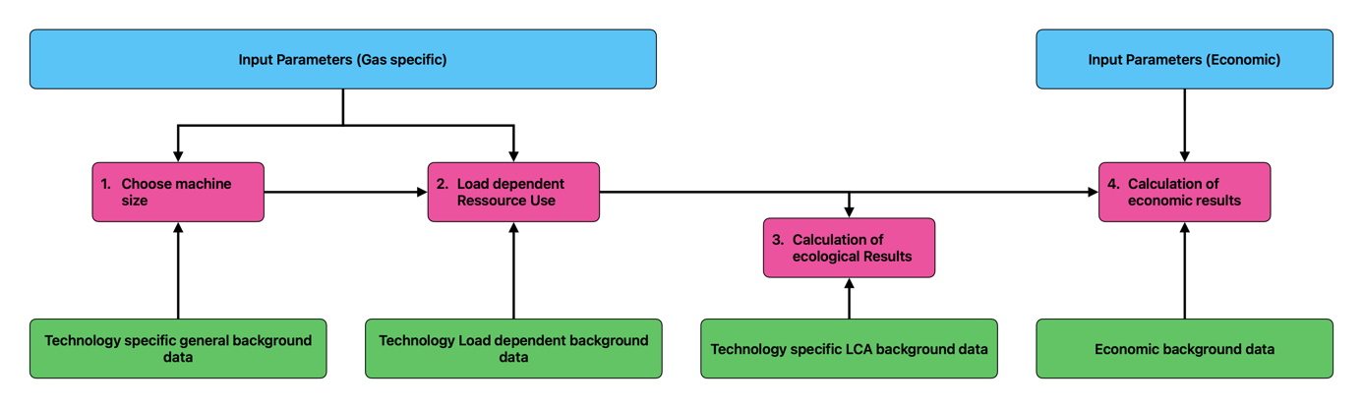

Figure 1: Simplified flowchart of the model concept

Some of these parameters (like the tax-rate or energy price) are predefined by the background data but can be changed manually by the user.

The gas specific parameters have the biggest impact on the tool calculations. These parameters define the development of the gas during the project time horizon. From the gas development the energy content for each year is calculated. Based on this energy content the tool chooses which machine size of each technology has the highest gas processing rate over the considered time period. The tool chooses the appropriate machine size. The further calculations are performed for the chosen machine. Based on the energy content the energetic load of the each technology gets calculated. From this point the quantity of operational resources can be calculated for each year and each technology. These results are the foundation for calculating the final ecological and economic results.

For the ecological results the quantity of calculated quantity of resources gets multiplied with the LCA-reference value for each operating resource and each impact category. If the tool calculated 500L of engine oil used for technology X in year n, this value will be multiplied with the LCA impact category specific value for the reference quantity of 1L engine oil.

The same procedure happens for the calculation of the economic results but in combination with the economic background data. In this case the 500L engine oil used for technology X in year n, will be multiplied with the price value for the reference quantity of 1L engine Oil.

For the calculation of the NPV the tool includes country specific taxes, tax compensation (if the cashflow was negative) and depreciation.

# 3. Model structure

In this chapter the model structure will be presented in more detail. For each technology the logic steps will be shortly described and visualized in detailed logic trees.

The logic trees include different logic blocks.

Blue: Input Parameters

Green: Background Data

Grey: Interim Results

Black: Math operators

Red: Error Message

Pink: Final Result

The background data is saved in CSV files. The logic trees show which data file is used and also which specific parameters of the file are used.

## Dual Fuel Engine (DFE):

The description of the DFE calculation processes will be divided into six sub chapters:

1. **DFE General calculations**

This chapter includes the calculation of the Gas development over the defined time horizon as well as the energy content. It also includes the calculation processes for choosing the correct engine size. For the calculation of the development of the average CH4 content and the average volume flow, the tool uses the following Input Parameters:

* Initial gas volume [m^3/h in year 1]
* Initial methane content [% in year 1]
* Time horizon [years]
* K-value

Based on this it calculates the total energetic value of the landfill gas for each year. As for DFE Diesel is used, the model calculates the energetic value of the used Diesel and ads it to the total energetic value for each year. Afterwards the model calculates the engine load for each engine size. Based on the engine limitation the model finally decides if engine size X is usable in year n or not. It then calculates which engine size processes the biggest amount of LFG over the total time horizon and chooses this engine size for further calculations. For years in which the engine isn’t usable the tool assumes that the gas is flared. **Figure 2** shows the specific logic tree.

1. **DFE Interim Results:**

For the interim results, two logic trees were created. One logic tree shows the calculating of general interim results and one logic tree shows the calculation of load dependent interim results.

The general interim results include the calculation of the thermal and electrical energy that is produced in each year. It depends on the specific engine efficiency (thermal and electric) as well as the total energetic value of landfill gas and Diesel. Furthermore, the logic tree shows the calculation of the flare operating resources, for the years n where the specific engine can’t be used. Those include flare maintenance and electricity used and it is assumed that the amount is not load dependent. The logic tree also shows the calculation of the flare emissions, based on the yearly amount of gas.

The logic tree is presented in **Figure 3.**

The load dependent interim results logic tree shows the calculation of the load dependent operating resources. These include the Fuel Consumption, the electricity consumption, the maintenance, the coolant consumption, the oil consumption and the amount of emissions.

To calculate the values the tool compares the yearly load of the engine with the load specific values in the background data of the specific engine and chooses the correct value. In some cases, the load specific values are also multiplied with engine specific values. For example for the oil consumption the load specific values are indicated in “operating hours until oil has to be changed”. If the oil has to be changed twice in a year, the values is multiplied with the oil tank volume in the engine specific background data.

The logic tree is presented in **Figure 4**.

1. **DFE Final ecological results:**

The logic tree in **Figure 5** shows how the different interim results were combined with the background LCA reference data. The ecological impact is calculated for the engine production, for the operating resource consumption of the engine and the flare as well as for the emissions of the engine and the flare. For the engine production the tool calculates the impacts only performed for one point in time. The production impacts aren’t allocated on the total time horizon. As in the future the LCA data will only be collected and calculated for the prototype engine, the tool assumes that the production impacts of other engine sizes can be calculated by simply multiplying the LCA results of the prototype engine with a realistic factor. This assumption is possible as the different engines have the same function and just differ in size.

For determining this factor in the future it is proposed to compare the prototype engine weight with the weight of comparable engines with higher capacities.

In this logic tree the pink logic blocks sum the results for each year and each impact category as the calculation steps are always similar.

In total the tool calculates the ecological results for eight processes. These processes are summarized in four main categories.

1. **DFE Final economic results:**

The logic tree in **Figure 6** shows how the different economic background reference data was combined with the interim results and the input values to calculate the final economic results.

The tool calculates the revenue based on thermal and electrical energy production as well as the energy price. It uses the same input energy price to calculate the costs for the consumed energy. In a real scenario this assumption might not be correct because energy purchase prices and energy sales prices are different. In this model it is assumed that the energy is used in house. This means that the assumed energy price equals the purchase price. Accordingly the tool assumes that the landfill operator can save purchasing 1 kWh of energy per each produced kWh. This way of balancing allows to assume that the energy sales price is the same like the price for purchasing energy.

For the calculation of the engine production price the tool uses the same approach as in the ecological chapter. It is assumed that the investment price of the prototype engine is available and that the price for the other engine sizes can be calculated with a factor.

In total the tool calculates ten economic results and summarizes them into five final categories.

1. **DFE Final NPV calculation:**

The final DFE logic tree in **Figure 7** shows the calculation of the NPV. For the calculation of taxes the model takes into account the depreciation. It also considers tax compensation for years where the revenue was negative. The depreciation is country specific but can also be entered manually. The NPV is calculated with the following formular, taking into account an adjustable interest rate:

$$NPV= - investmnet \left[€\right]+\sum_{n=1}^{n}{\frac{{Cashflow}_{n}}{(1+i)^{n}}}$$

On the following pages all DFE logic trees are presented.

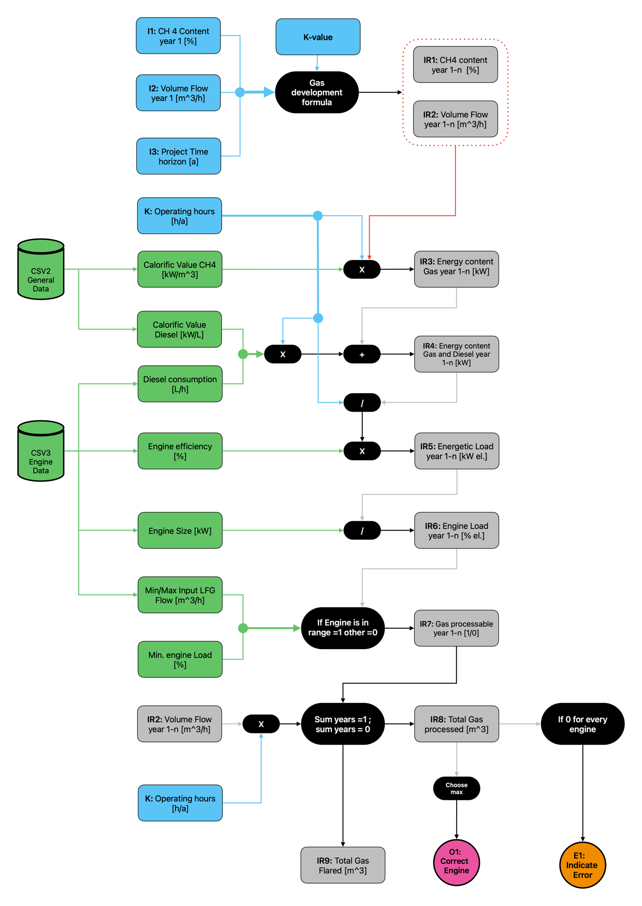

Figure 2: Logic Tree DFE - gas development and engine size



Figure 3: Logic tree DFE - general and flare specific interim results

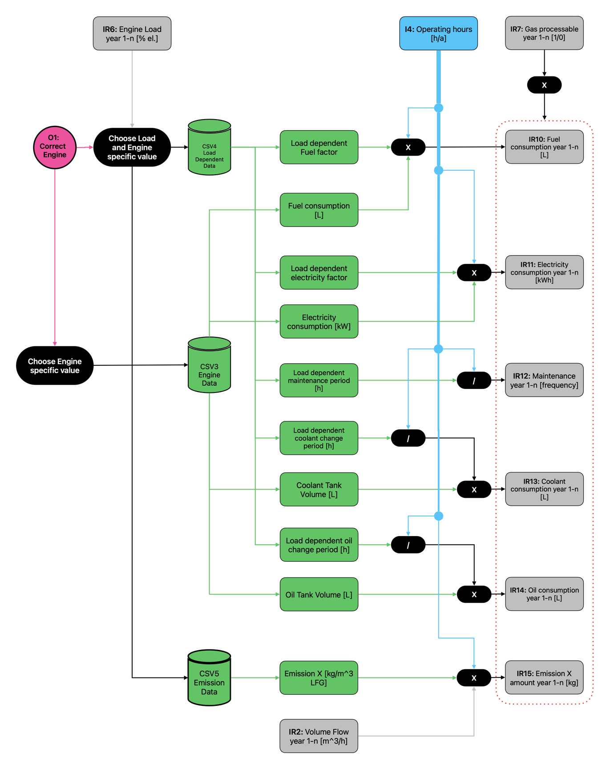

Figure 4: Logic Tree DFE - Load dependent interim results

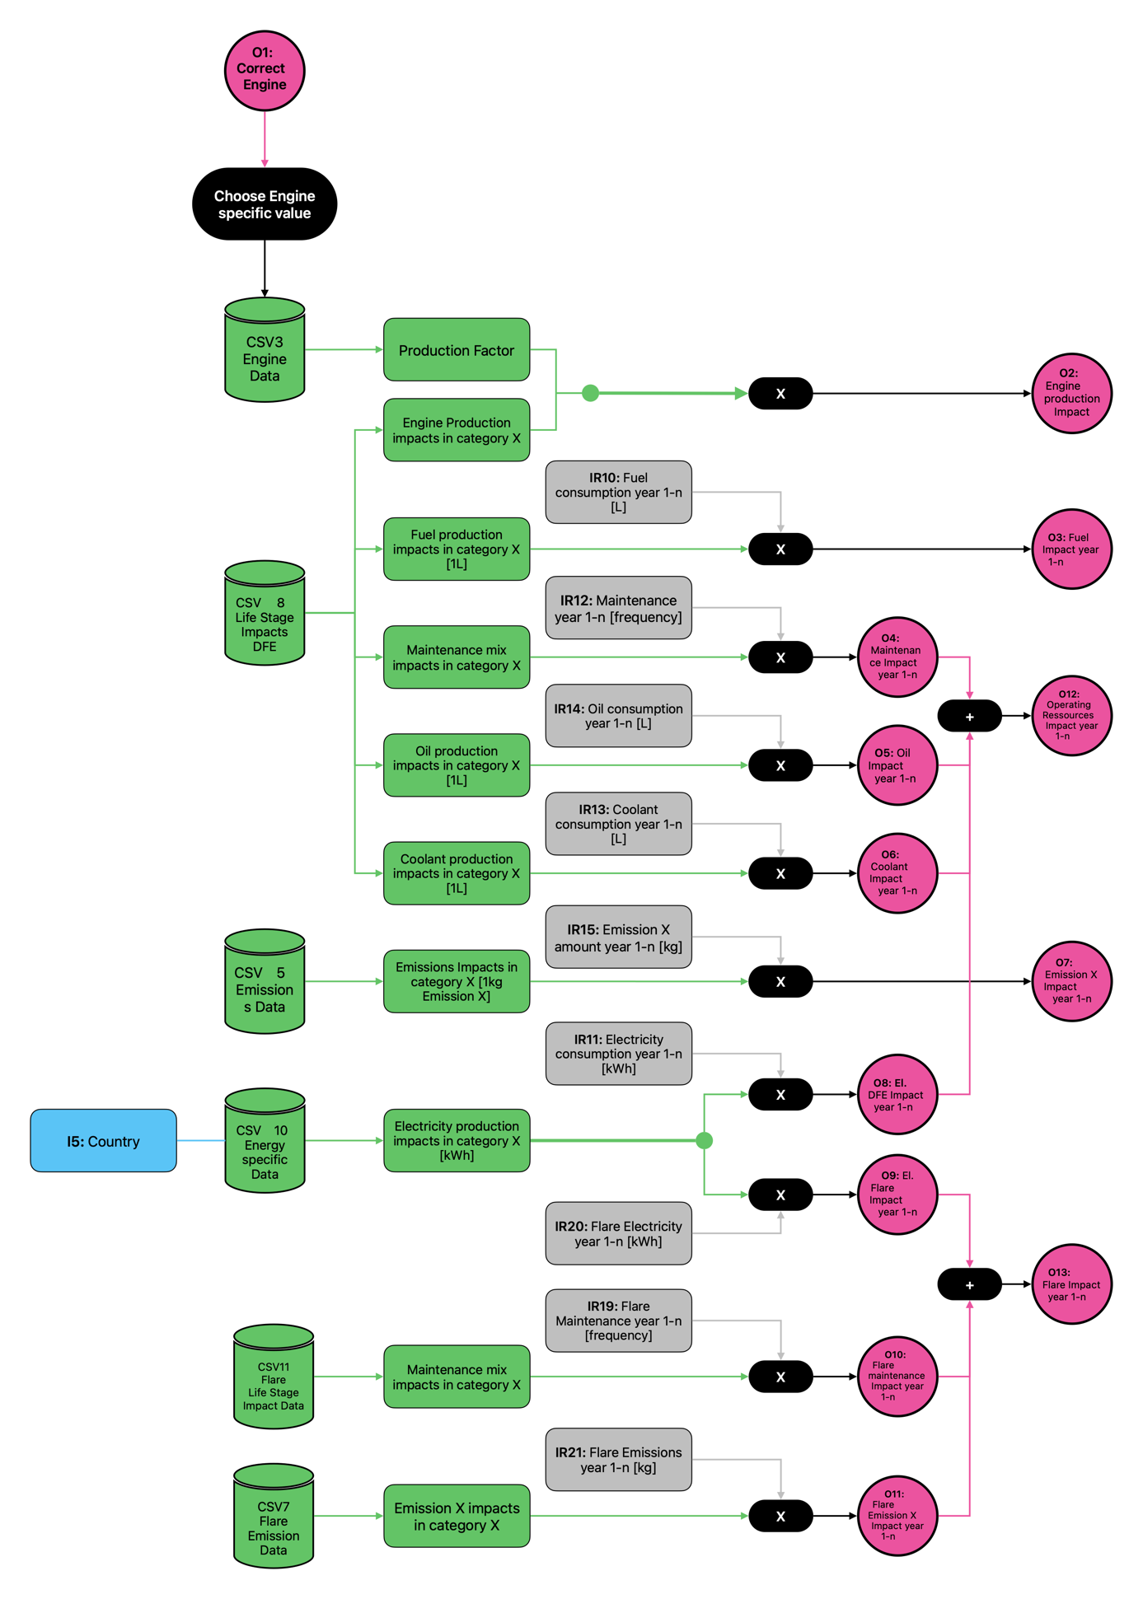

Figure 5: Logic tree DFE - Ecological Results

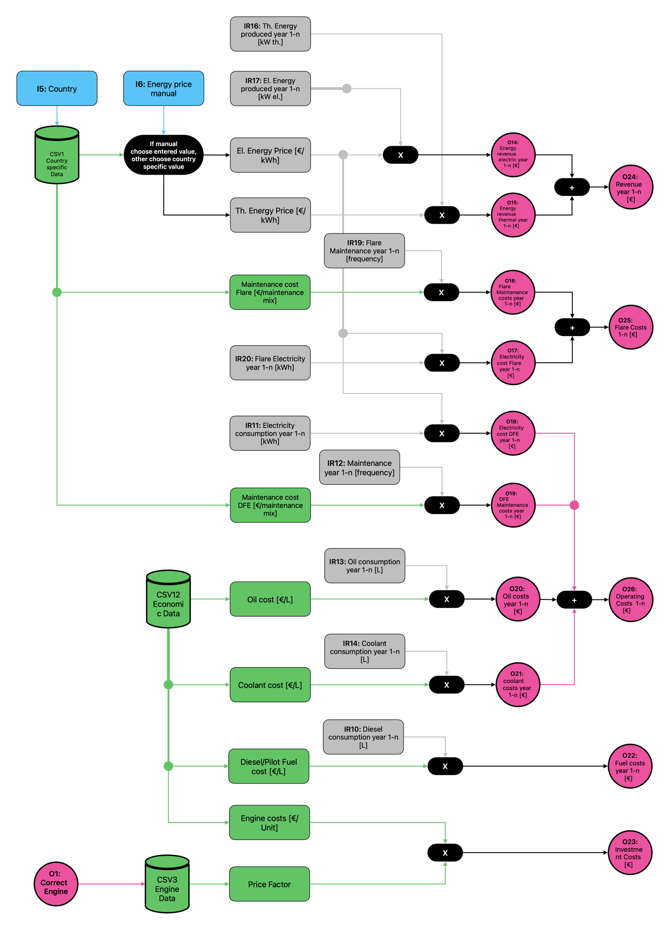

Figure 6: Logic Tree DFE - Economic results

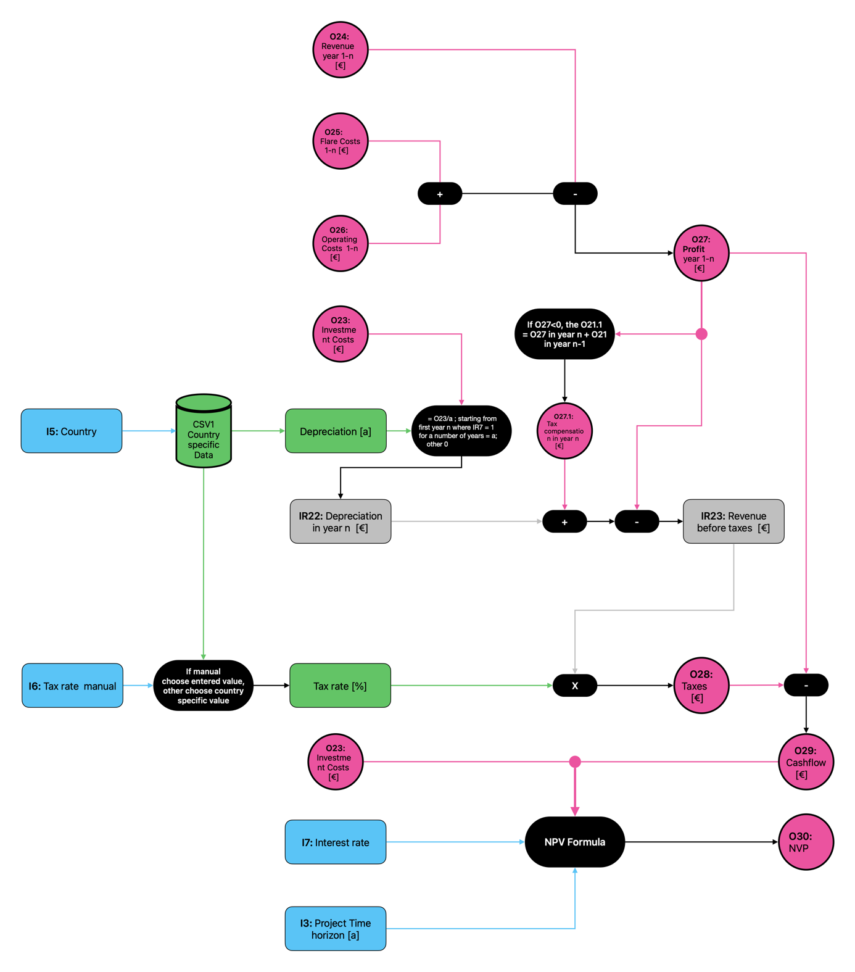

Figure 7: Logic Tree DFE - NPV calculation

## Oxygen Enrichment Combustion (OEC):

The description of the OEC calculation processes will be divided into six sub chapters:

1. **OEC General calculations**

The calculation of the gas development is shown in each general logic tree but is only performed ones in the model and always uses the same results. The calculation process is described in the DFE chapter.

Based on the results the tool calculates the total energetic value of the landfill gas for each year. Afterwards the model calculates the engine load for each engine size. Based on the engine limitation the model finally decides if engine size X is usable in year n or not. It then calculates which engine size processes the biggest amount of LFG over the total time horizon and chooses this engine size for further calculations. For years in which the engine isn’t usable the tool assumes that the gas is flared. **Figure 8** shows the specific logic tree.

1. **OEC Interim Results:**

For the interim results, two logic trees were created. One logic tree shows the calculating of general interim results and one logic tree shows the calculation of load dependent interim results.

The general interim results include the calculation of the thermal and electrical energy that is produced in each year. It depends on the specific engine efficiency (thermal and electric). All other calculations equal the ones presented in the DFE chapter.

The logic tree is presented in **Figure 9**.

The load dependent interim results logic tree shows the calculation of the load dependent operating resources. These include the Oxygen Consumption, the electricity consumption, the maintenance, the coolant consumption, the oil consumption and the amount of emissions.

The calculation logic equals the one in the DFE chapter. The logic tree is presented in **Figure 10**.

1. **OEC Final ecological results:**

The logic tree in **Figure 11** shows how the different interim results were combined with the background LCA reference data for OEC. The ecological impact is calculated for the engine production, for the operating resource consumption of the engine and the flare as well as for the emissions of the engine and the flare.

In general, the calculation logic is the same as presented in the DFE chapter. For OEC fuel consumption wasn’t relevant but instead oxygen consumption had to be taken into account.

1. **OEC Final economic results:**

The logic tree in **Figure 12** shows how the different economic background reference data for OEC was combined with the interim results and the input values to calculate the final economic results.

In general, the calculation logic is the same as presented in the DFE chapter. For OEC fuel consumption wasn’t relevant but instead oxygen consumption had to be taken into account.

1. **OEC Final NPV calculation:**

The final OEC logic tree in **Figure 13** shows the calculation of the NPV. For the calculation of taxes the model takes into account the depreciation. It also considers tax compensation for years where the revenue was negative. The depreciation is country specific but can also be entered manually. The NPV is calculated with the following formular, taking into account an adjustable interest rate:

$$NPV= - investmnet \left[€\right]+\sum_{n=1}^{n}{\frac{{Cashflow}_{n}}{(1+i)^{n}}}$$

On the following pages all OEC logic trees are presented.

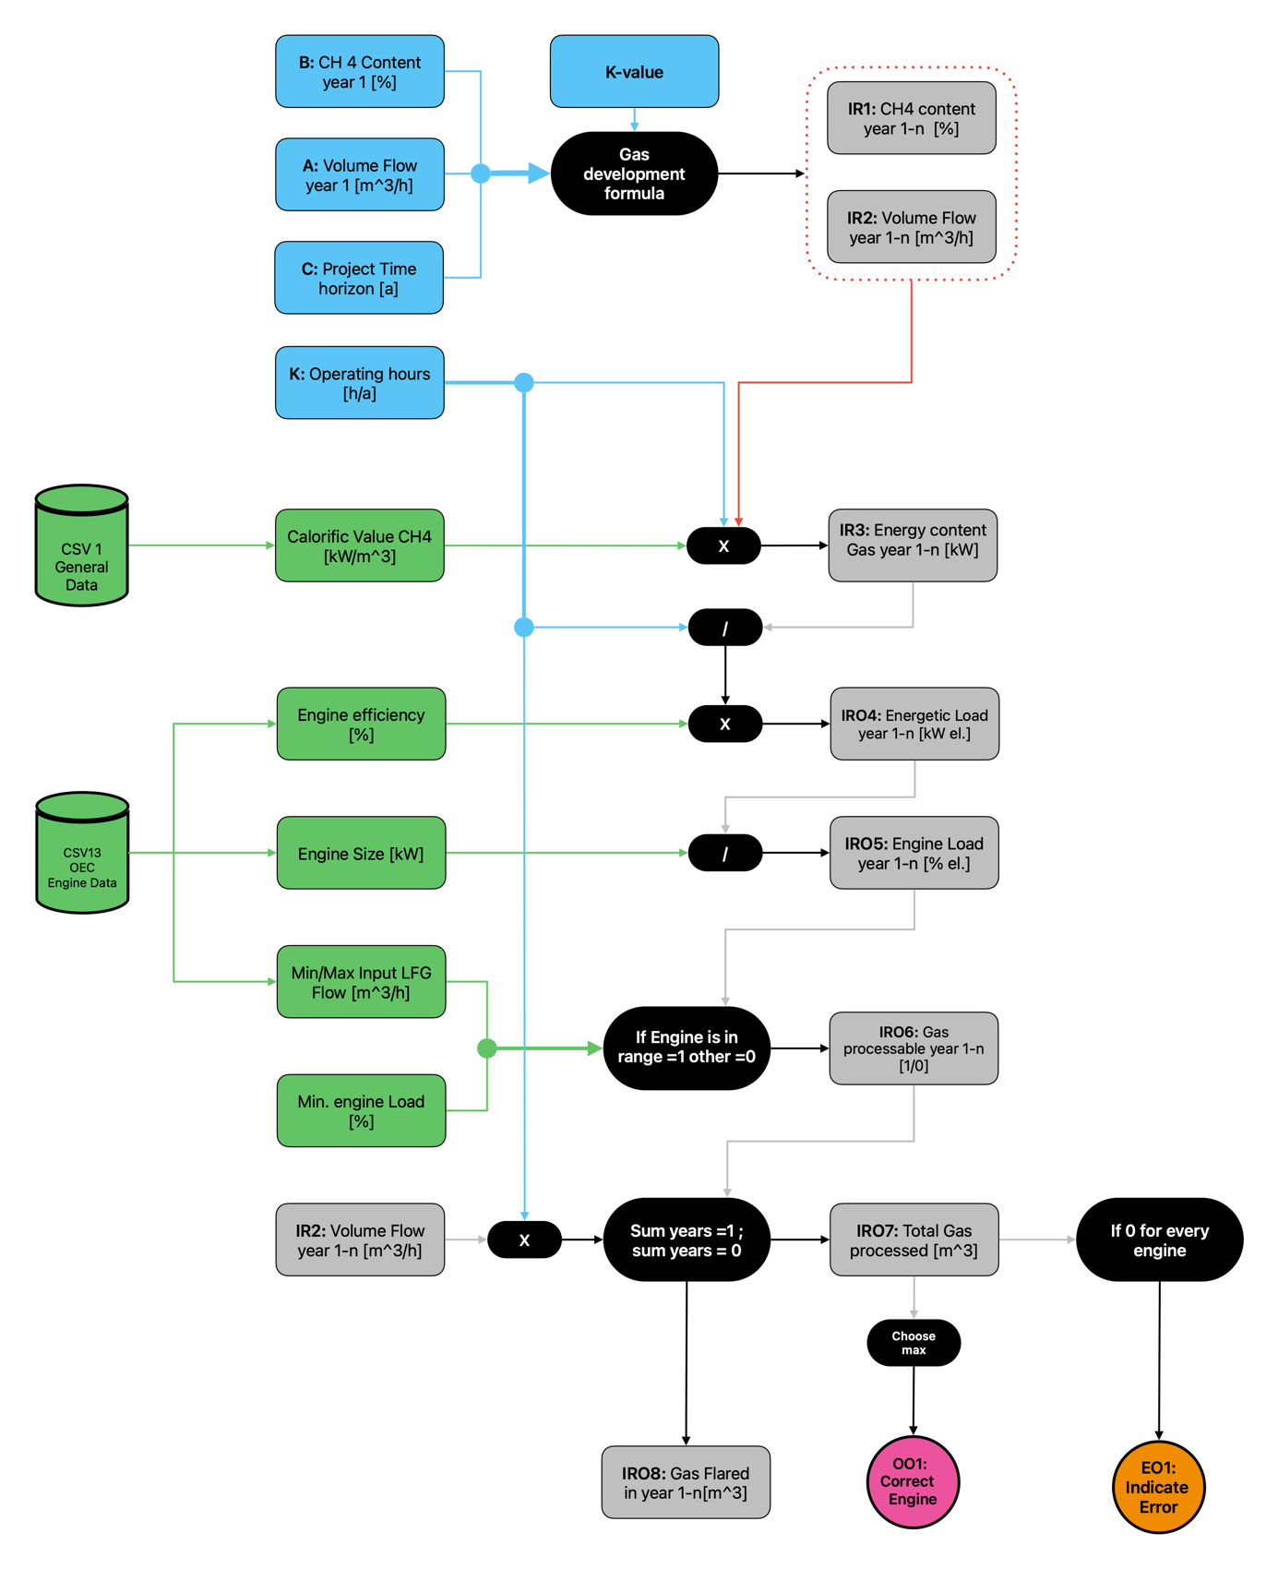

Figure 8: Logic Tree OEC - General calculations

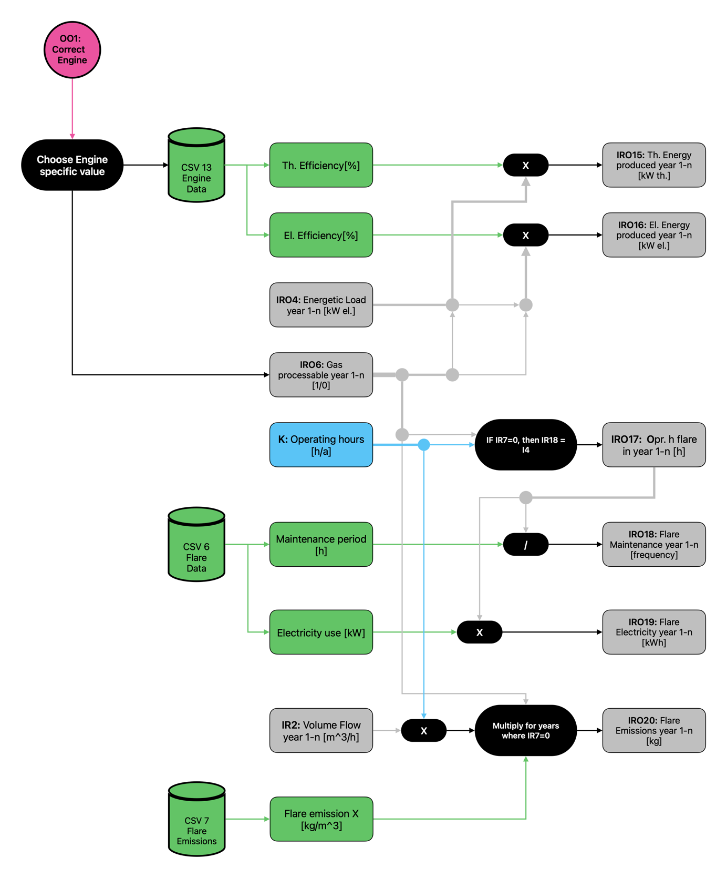

Figure 9: Logic Tree OEC - Interim results general

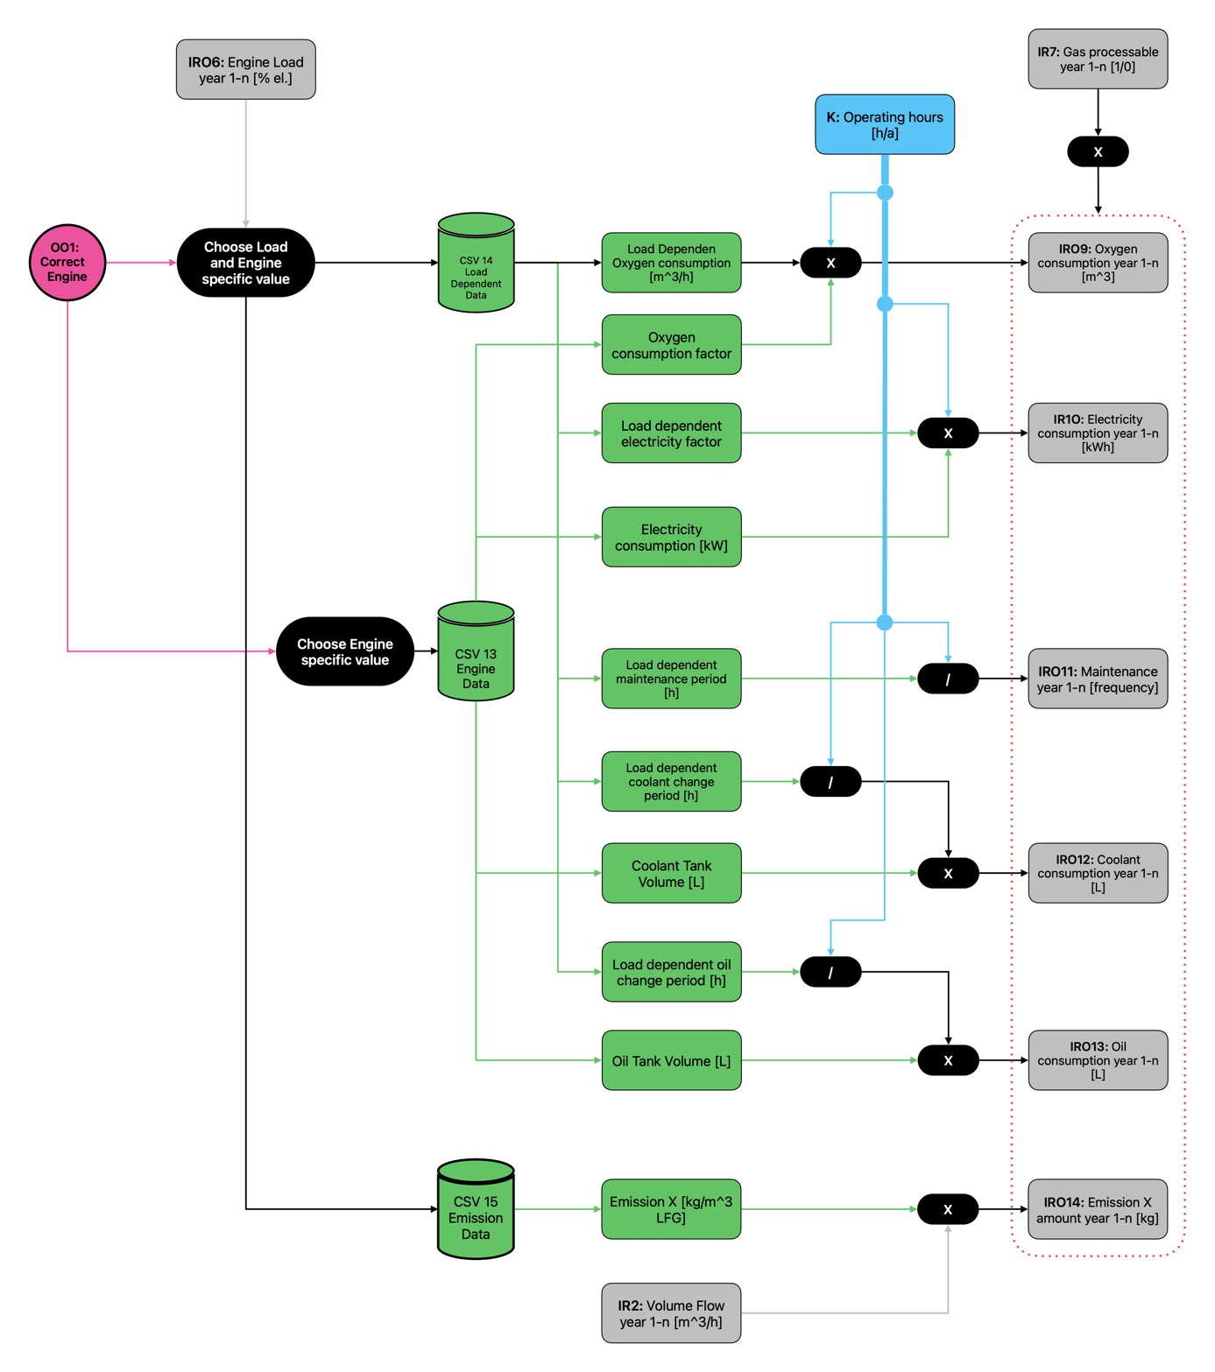

Figure 10: Logic Tree OEC - Load dependent interim results

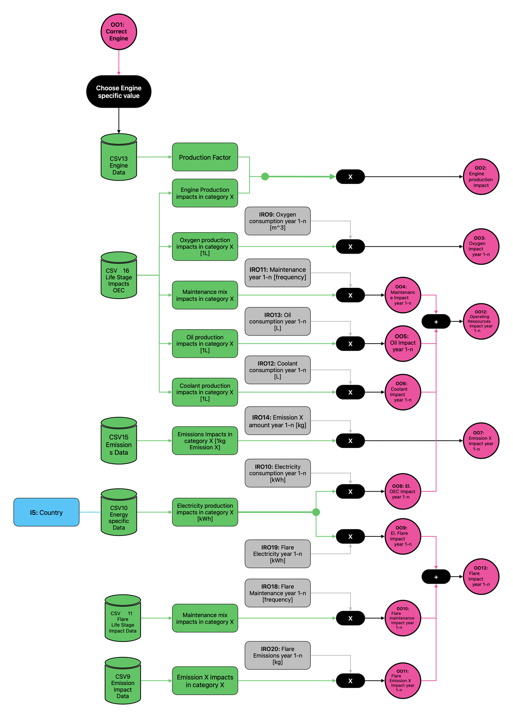

Figure 11: Logic Tree OEC - Ecological results

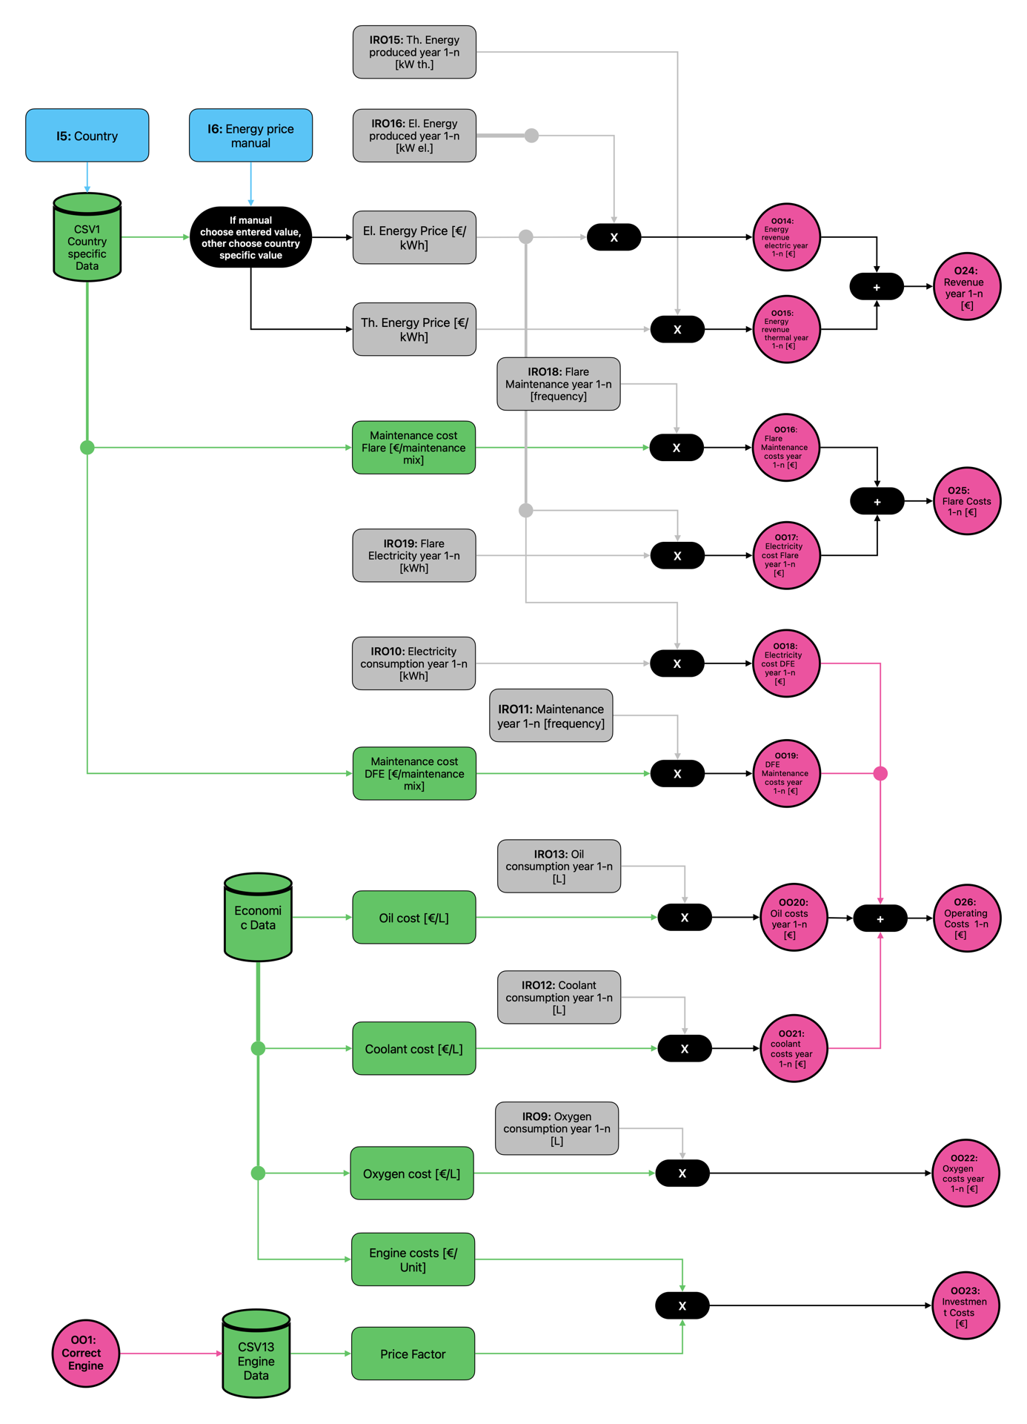

Figure 12: Logic Tree OEC - Final Economic Results

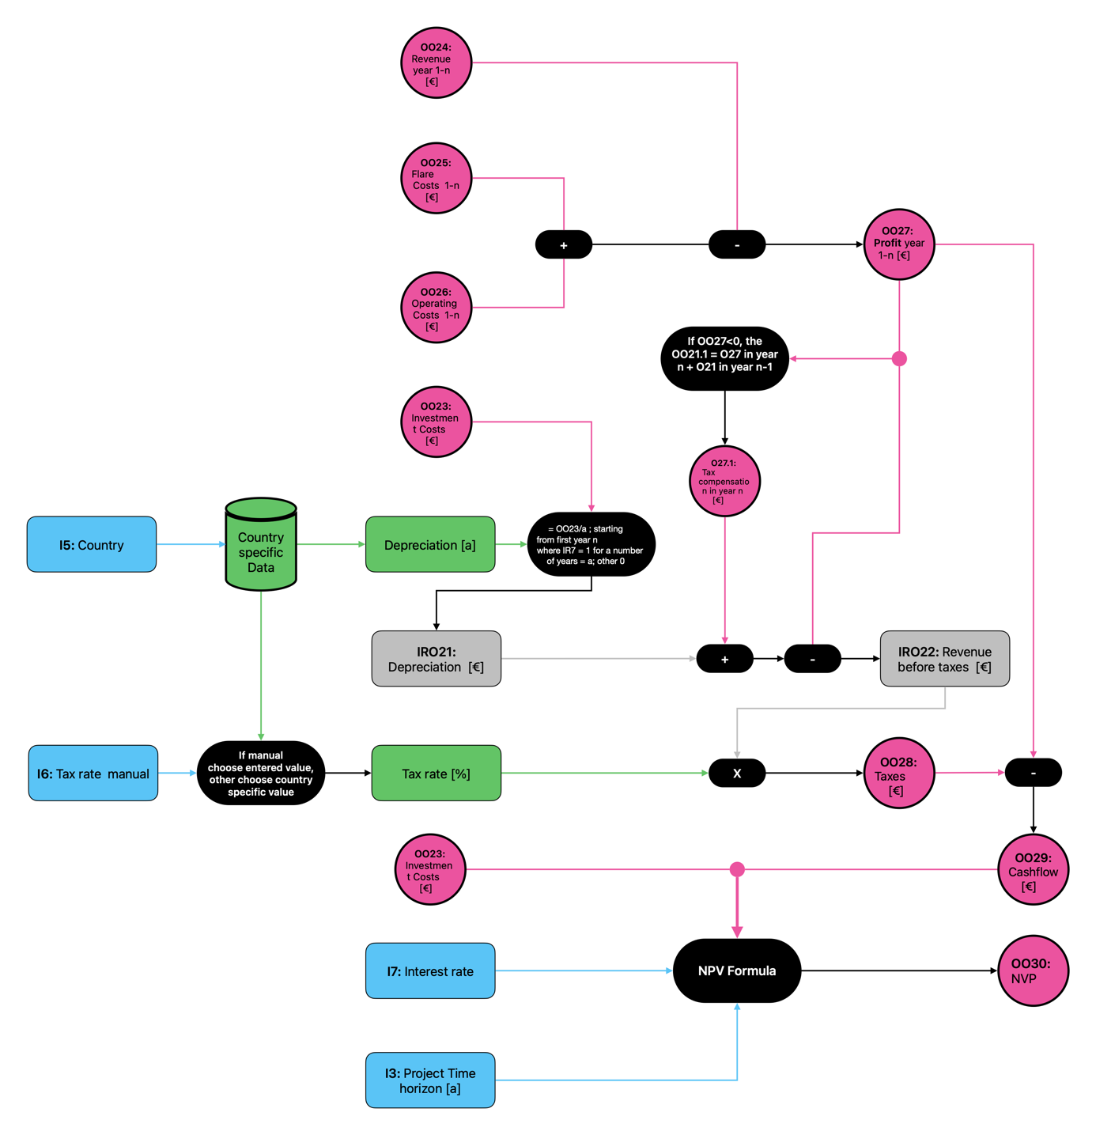

Figure 13: Logic Tree OEC - Final NPV calculation

## Spinning Fluids Reactor (SFR)

As SFR is an upgrading technology further processing has to be assumed to compare the results with the other two technologies. For that it was assumed that the upgraded gas will be energetically processed with a CHP unit. The tool user can decide in the input parameters if the CHP unit is already available at the landfill or if it has to be bought. The description of the SFR calculation differ from the two previous technologies and will be divided into ten subchapters.

1. **SFR choose unit size**

The calculation of the gas development is shown in each general logic tree but is only performed ones in the model and always uses the same results. The calculation process is described in the DFE chapter.

Based on the results the tool calculates the total energetic value of the landfill gas for each year. Afterwards the model calculates the SFR Unit load for each SFR Uni size. Based on the SFR Unit limitation the model finally decides if Unit size X is usable in year n or not. It then calculates which Unit size processes the biggest amount of LFG over the total time horizon and chooses this engine size for further calculations. For years in which the engine isn’t usable the tool assumes that the gas is flared. **Figure 14** shows the specific logic tree.

1. **SFR choose CHP engine size**

Based on the results the tool SFR calculations the total energetic value of the upgraded landfill gas for each year. Afterwards the model calculates the CHP engine load for each CHP engine size. Based on the CHP engine limitations the model finally decides if engine size X is usable in year n or not. It then calculates which engine size processes the biggest amount of LFG over the total time horizon and chooses this engine size for further calculations. If the SFR unit is capable to process gas but the CHP unit isn’t, it is assumed that none of the machines will operate. For years in which the engine isn’t usable the tool assumes that the gas is flared.shows the specific logic tree. The logic tree is presented in **Figure 15**.

1. **SFR Load dependent Interim Results:**

For SFR only one interim results logic tree for load dependent parameters was created. This tree includes the calculation of chemical consumption, the electricity consumption and the maintenance. The calculation logic equals the one in the DFE chapter. The logic tree is presented in **Figure 16**.

1. **SFR Interim Results CHP**

For the interim results of CHP, two logic trees were created. One logic tree shows the calculating of general interim results and one logic tree shows the calculation of load dependent interim results.

The general interim results include the calculation of the thermal and electrical energy that is produced in each year. It depends on the specific engine efficiency (thermal and electric). All other calculations equal the ones presented in the DFE chapter.

The logic tree is presented inFigure 17.

The load dependent interim results logic tree shows the calculation of the load dependent operating resources. These include the the electricity consumption, the maintenance, the coolant consumption, the oil consumption and the amount of emissions.

The calculation logic equals the one in the DFE chapter. The logic tree is presented in **Figure 18**.

1. **SFR ecological results**

The logic tree in Figure 20shows how the different interim results for SFR were combined with the background LCA reference data for SFR. The ecological impact is calculated for the SFR unit production and for the operating resource consumption of the unit.

In general, the calculation logic is the same as presented in the DFE chapter.

The logic tree in Figure 19shows the calculation logic for the CHP engine ecological results. The CHP engine logic also includes the calculation for the flare impacts as well as for the emissions of both, flare and CHP engine. The CHP engine production is only considered if the user chose that no CHP engine is available in the unput tab.

In general, the calculation logic is the same as presented in the DFE chapter.

1. **SFR Final economic results:**

The logic tree in **Figure 21** shows how the different economic background reference data for the SFR unit was combined with the interim results and the input values to calculate the final economic results.

The logic tree in **Figure 22** shows how the different economic background reference data for the CHP engine was combined with the interim results and the input values to calculate the final economic results.

In general, the calculation logic is the same as presented in the DFE chapter. For OEC fuel consumption wasn’t relevant but instead oxygen consumption had to be taken into account.

1. **SFR Final NPV calculation:**

The final OEC logic tree in Figure 23shows the calculation of the NPV. For the calculation of taxes the model takes into account the depreciation. It also considers tax compensation for years where the revenue was negative. The depreciation is country specific but can also be entered manually. The NPV is calculated with the following formular, taking into account an adjustable interest rate:

$$NPV= - investmnet \left[€\right]+\sum_{n=1}^{n}{\frac{{Cashflow}_{n}}{(1+i)^{n}}}$$

On the following pages all OEC logic trees are presented.

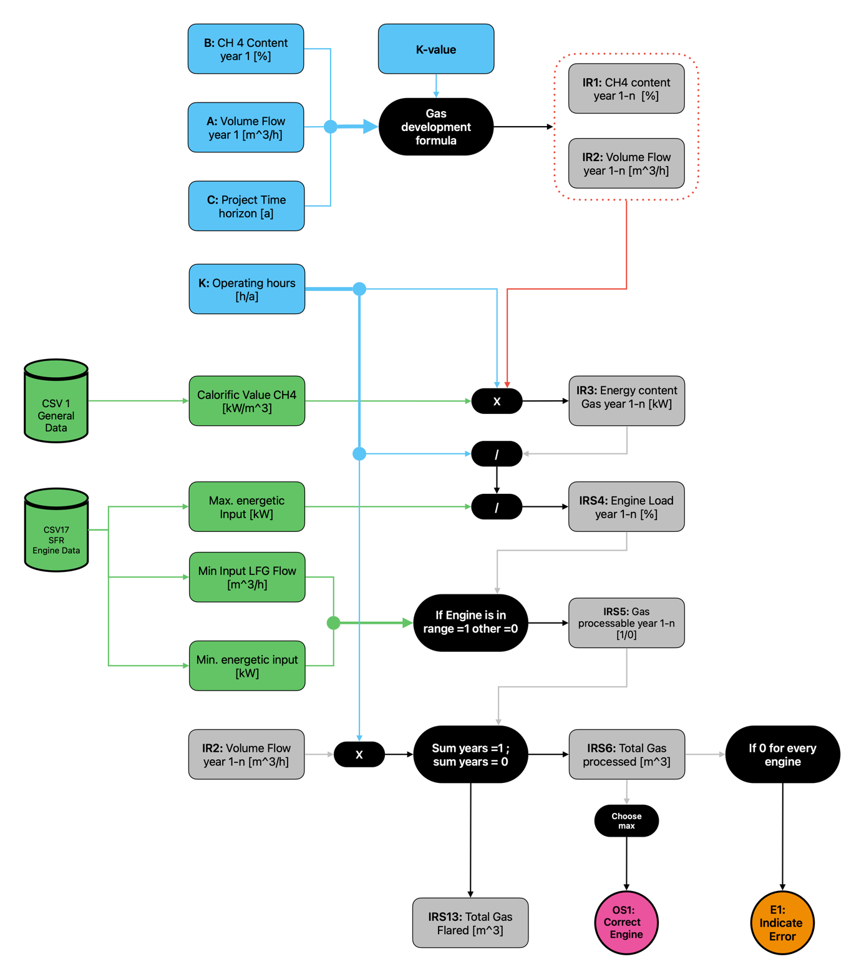

Figure 14: Logic Tree SFR - Choose SFR unit size

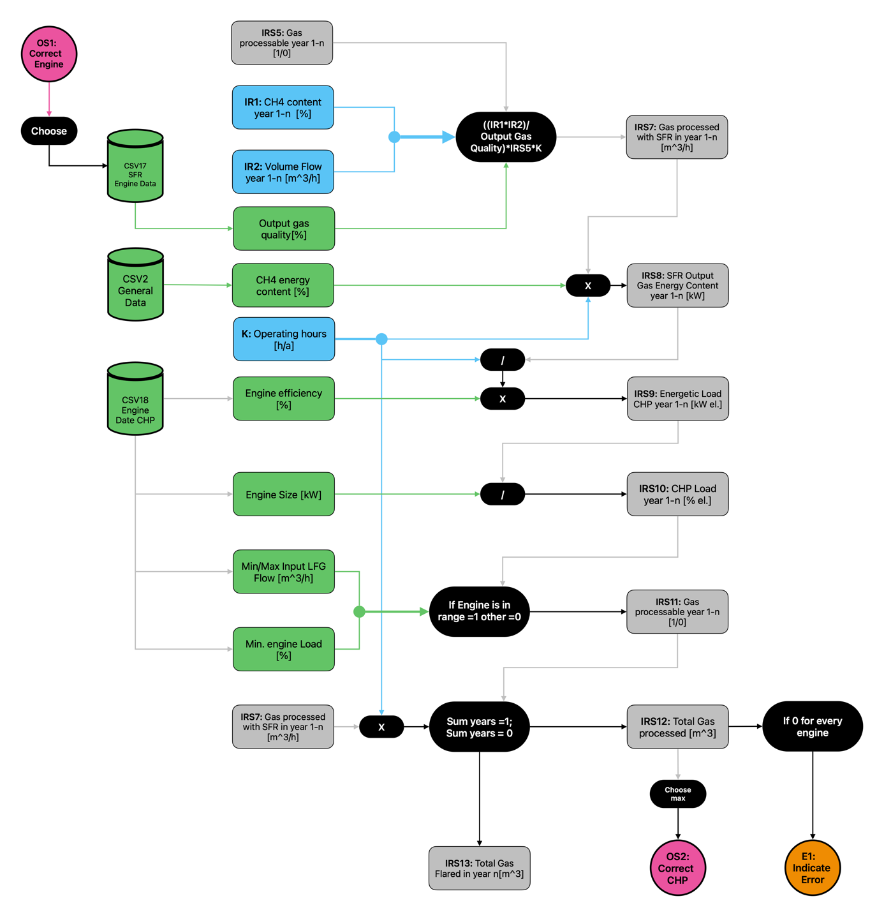

Figure 15: Logic Tree SFR - CHP Unit decision

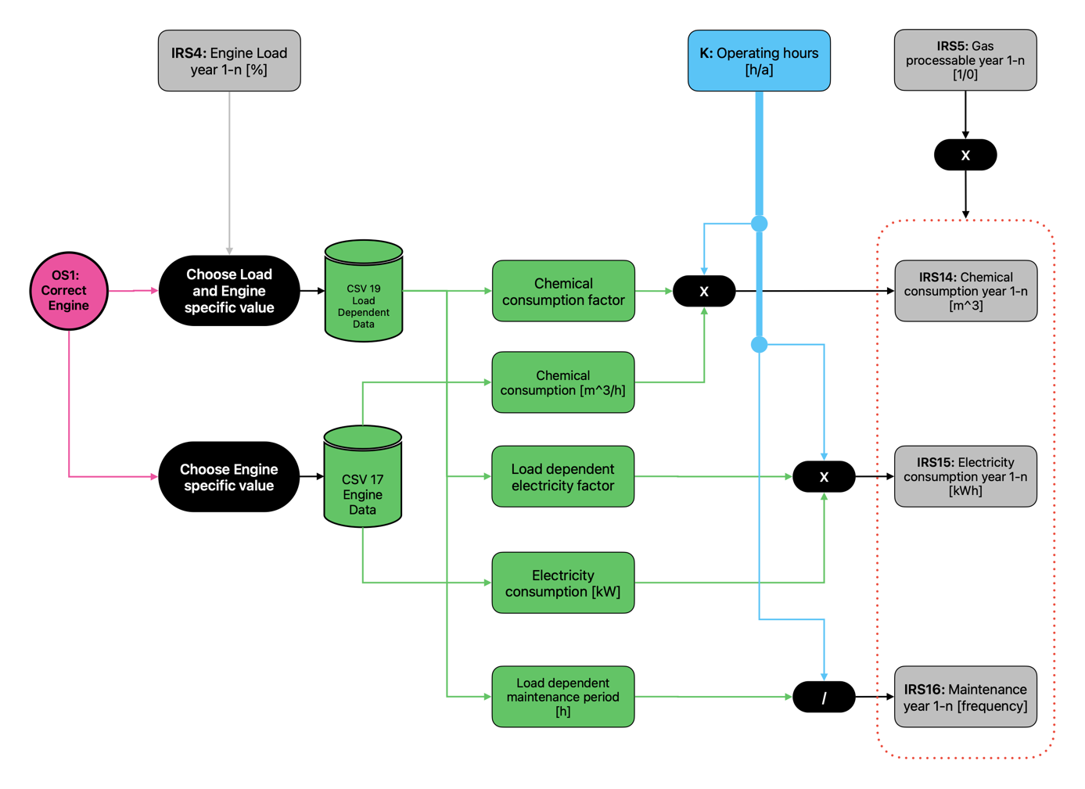

Figure 16: Logic Tree SFR - Load dependent results SFR

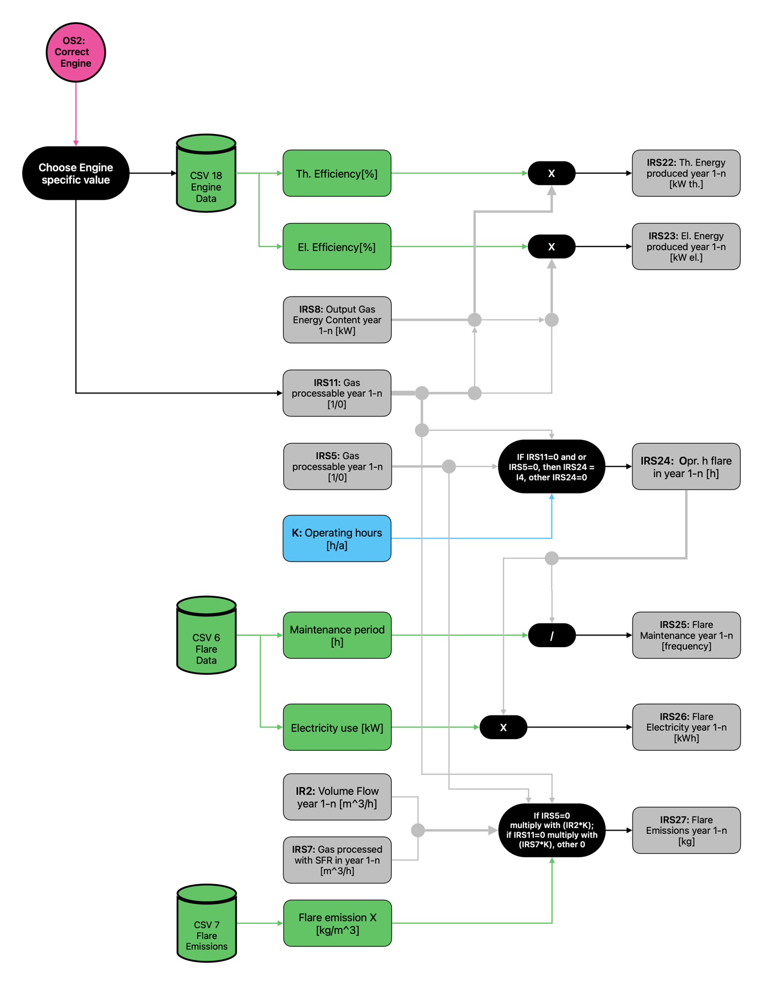

Figure 17: Logic Tree SFR - Interim Results CHP general

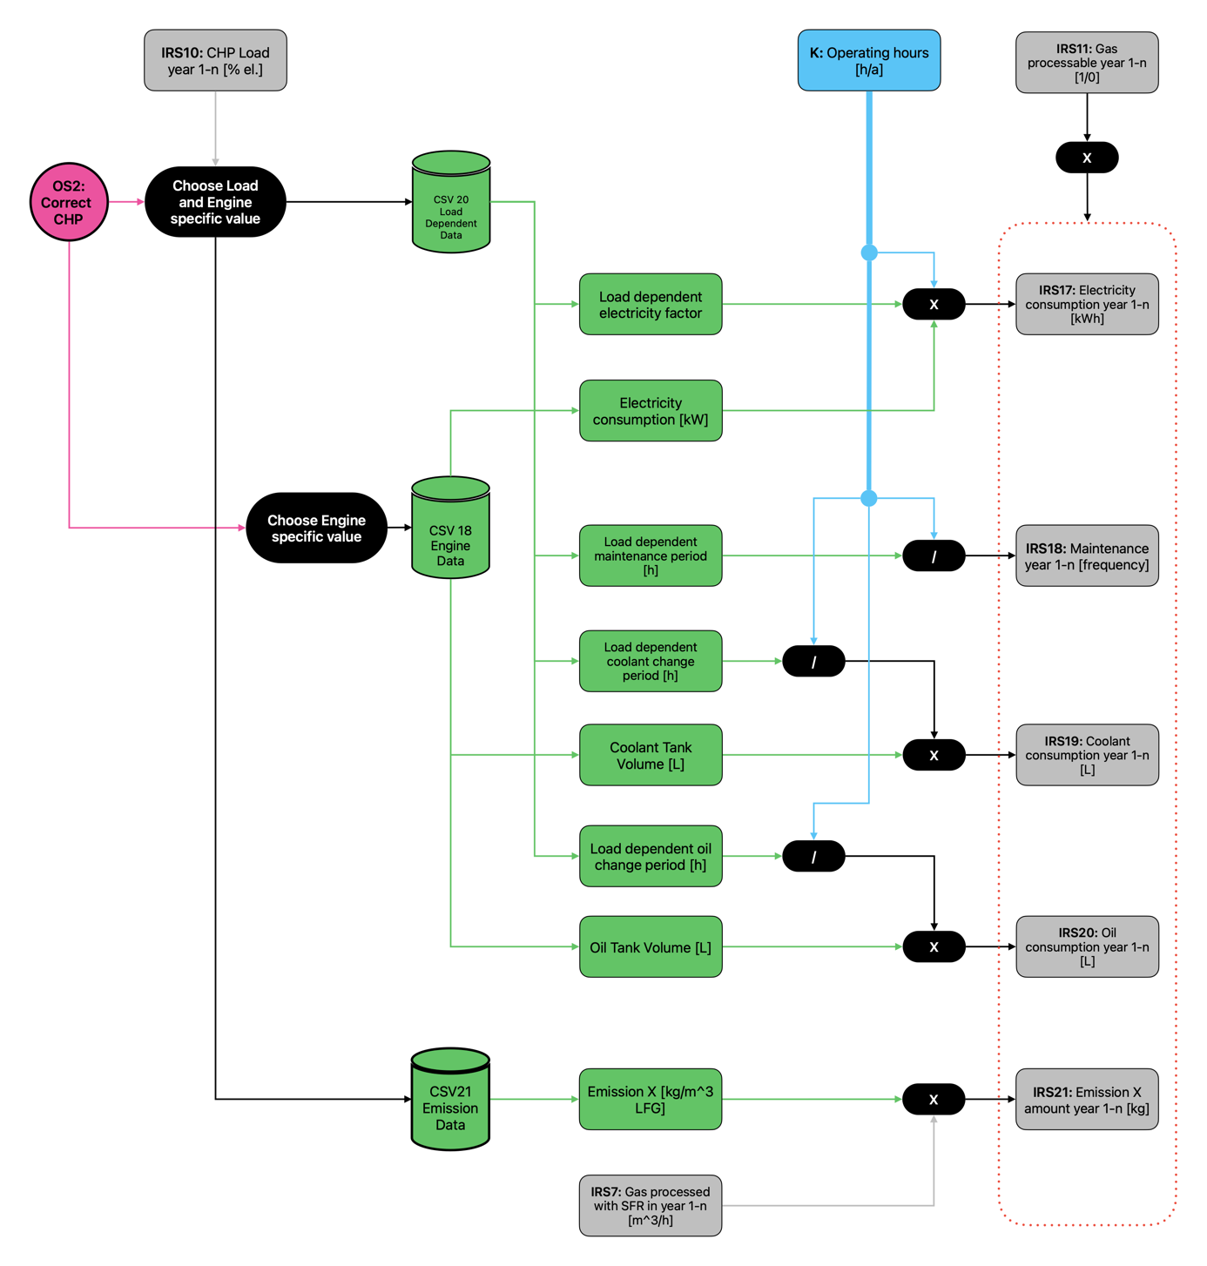

Figure 18: Logic Tree SFR - Interim Results CHP Load Dependent

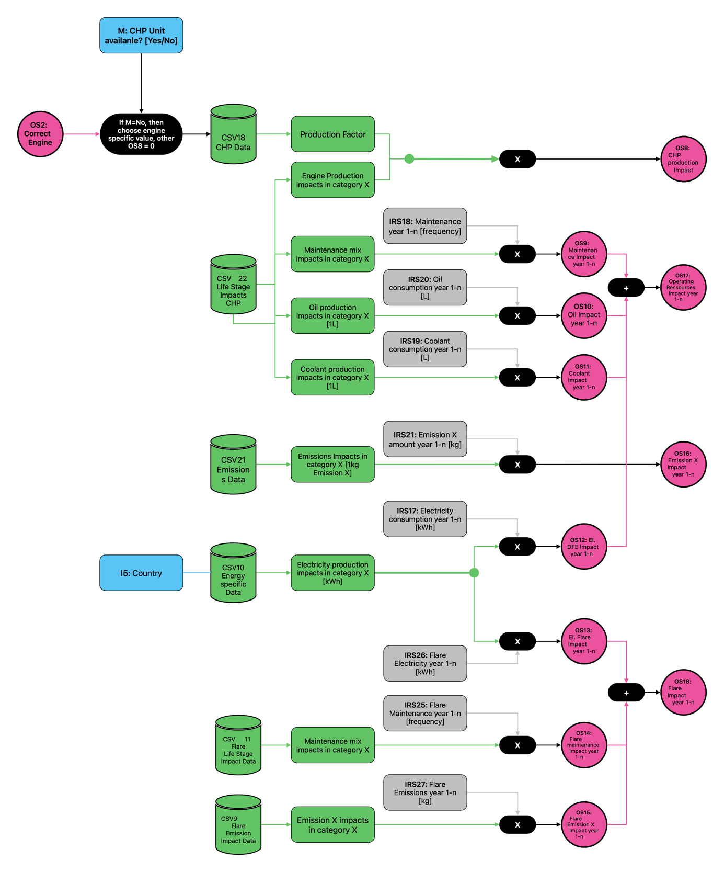

Figure 19: Logic Tree SFR - CHP engine ecological results

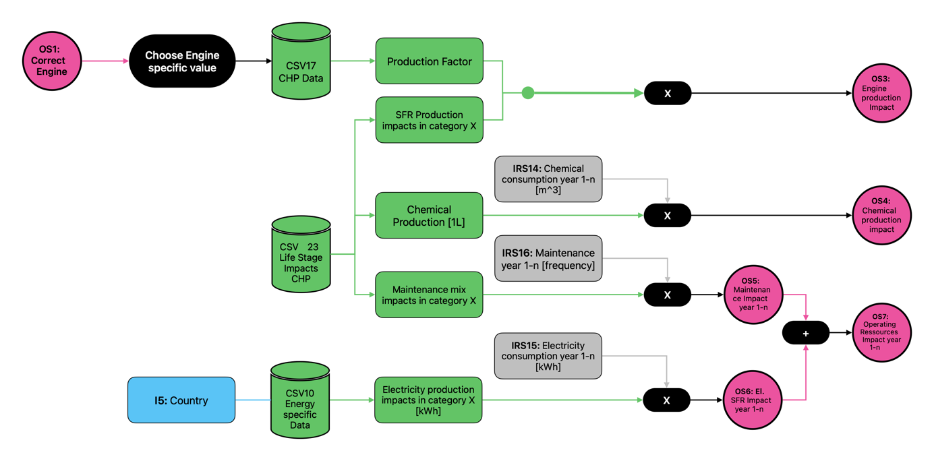

Figure 20: Logic Tree SFR: SFR unit ecological results

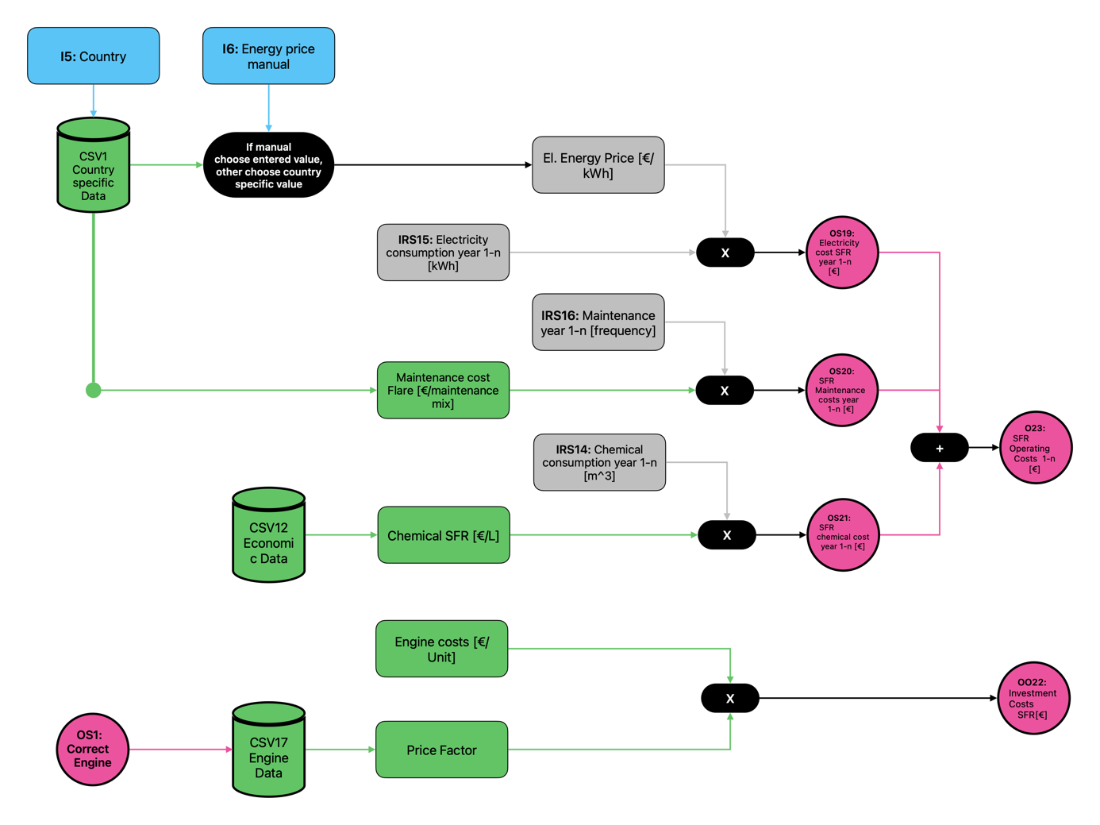

Figure 21: Logic Tree SFR - Final economic results SFR unit

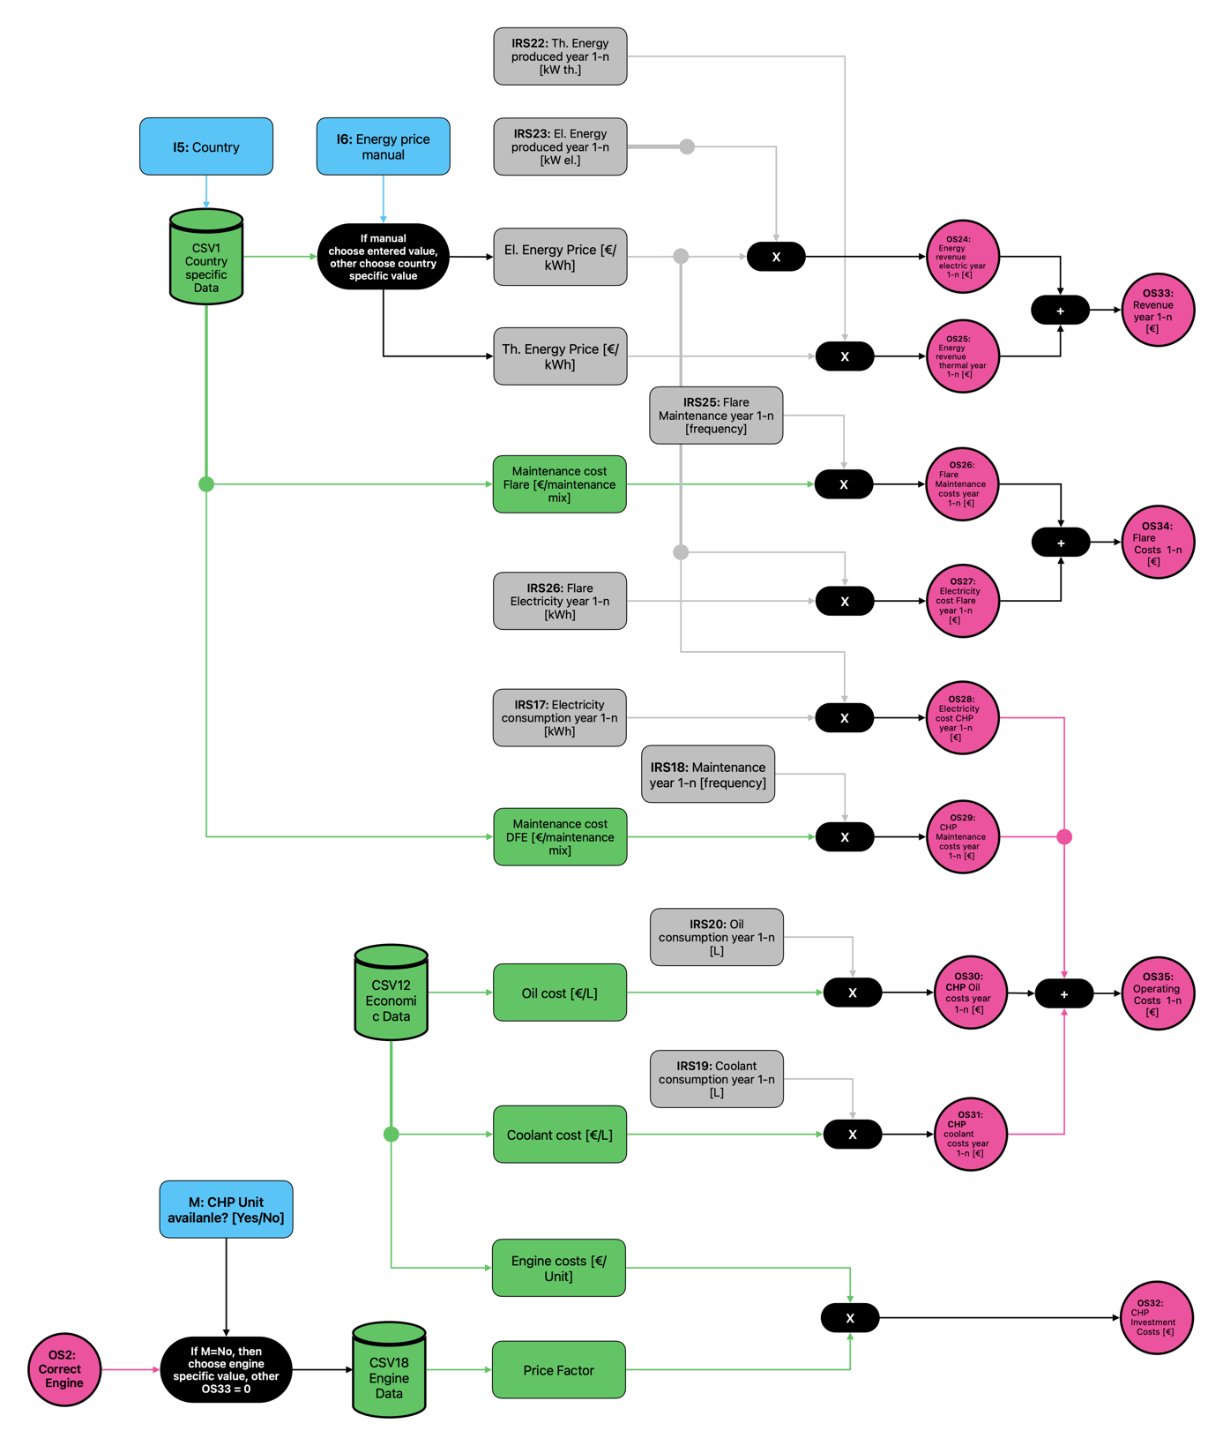

Figure 22: Logic Tree SFR: Final economic results CHP

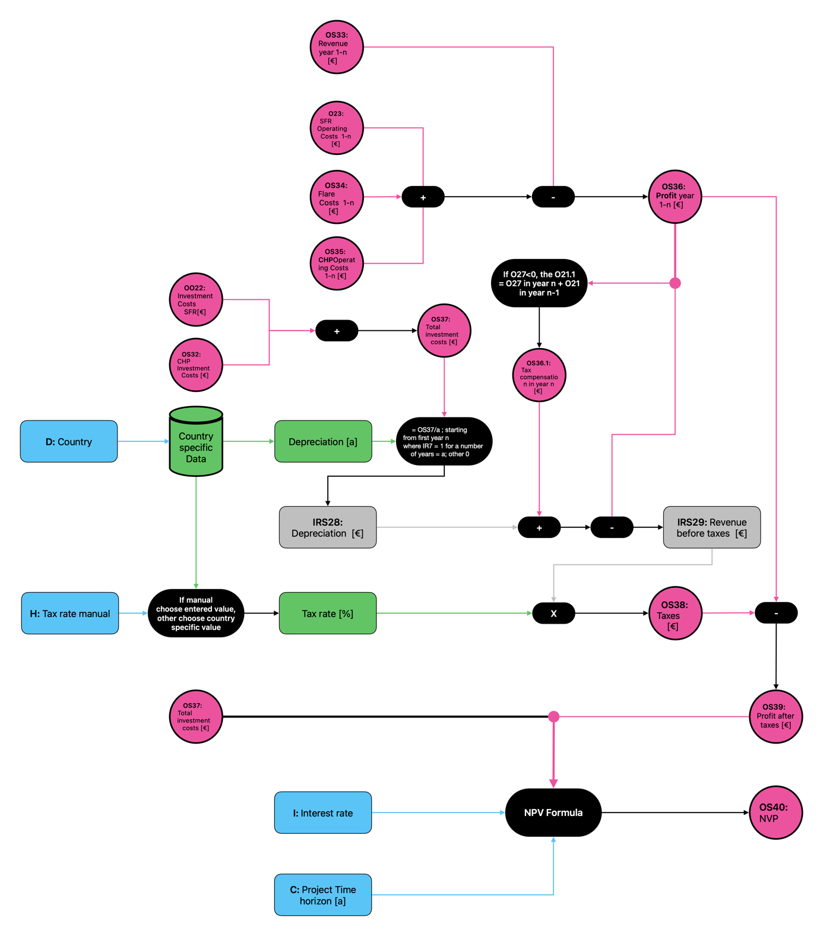

Figure 23: Logic Tree SFR - NPV calculation

# 4. Assumptions

The parametrization of the LCA-tool and the focus on real life scenarios made the implementation of the tool quite complex. At the same time the available data quantity was very low and also the planned data collection won’t allow to compensate all assumptions.

In this chapter the most important assumptions are presented:

1. **Gas development**

For the gas development a simplified formula based on the landGEM and the Weber model was used to estimate the quantity of gas volume flow and methane content during the time horizon.

It was assumed that the gas development is based on an exponential degrowth which is dependent from the indicated number of observed years and the k-value. This value represents the methane generation rate constant. The user is free to choose a certain k-value. As a preset the Clean Air Act (CAA) value of 0,05 is proposed. As real life landfillgas development depends from a lot of factors like waste composition, climate etc. the tool also leaves the possibility to enter manual values for each year of the observed time horizon. It is expected that the tool users already have estimations on the gas development. If this is not the case the users can calculate the values with models which were only designed to estimate landfill gas development and use the results as input values. Only for quick results the users should rely on the preset gas development function.

The formula to calculate the gas quantity is defined as:

$$Volume Flow in year n \left[\frac{m^{3}}{h}\right]=Volume Flow in year n-1*e^{-k*n}$$

The formula to calculate the methane content is defined as:

$$Methane year n \left[\%\right]=\frac{Methan year n-1*e^{-k*n}}{\left(Methan year n-1*e^{-k*n}\right)+(1-Methan year n-1)}$$

1. **Energy recovery method**

Although only one case in the planned trials will test electrical and thermal energy generation, the tool assumes that this both kinds of utilization will take place for all technologies. This is primarily because comparable results are to be achieved.

1. **Different Engine Sizes:**

Although only one size is examined for each technology in the planned trials, the tool assumes that there are at least three machine sizes for each technology. This assumption is made because the project technologies are subject to real-world constraints. These limitations relate primarily to the amount of usable landfill gas and the usable energy content. In order to allow for a wider range of input scenarios, background data for different machine sizes was therefore created. This data will need to be reviewed at a later date and defined using assumptions that are as rational as possible.

1. **Load dependent assumptions**

It is assumed that the machines have a different consumption of operating resources like engine oil, coolant, SFR-chemical or oxygen. These load dependent factors will have to be examined during the lab-scale tests and the pilot testing.

The load refers to the energetic load, meaning the ratio between LFG input energy content and the maximal processable energy content of the machines. Meaning an engine with the power 750 kW el. is at 100% load if the input energy content equals 750 kW. The tool thereby takes into account the engine efficiency. For the SFR technology the maximum load gets calculated from the maximum input gas quality and the targeted gas output quality (methane content).

For the change in emission quantity the same load value is used. It is assumed that at different loads, different quantities of emissions per m3 LFG get emitted. Those values also have to be examined during the lab-scale tests and the pilot testing.

In reality the functions of resource consumption and emissions are individually dependent on each: engine load, CH4 content and LFG volume flow. Since testing all relations in the experiments is not planned and would be too complex, this simplification was made.

For the flare technology load dependent change in resource consumption and emissions was assumed not to accure.

# 5. Technological implementation of the Web App

1. **Code development**

The webapp was developed using artificial intelligence. The concept and the calculation steps were developed and written in natural language. This concept was then prompted to different Ais for code development. The code was developed in Java Script (JS), HTML and CSS.

The prompt is linked in **appendix 1.**

1. **Background data**

The background data frames were originally created in Excel and then exported to CSV files and uploaded in a Git-Hb Repository. The code directly accesses the CSV files over the Git Hub repository. This means that the data values can be changed in the repository and will automatically be changed in the code.

If the CSV Files are updated it is important to keep the names of table headers as those are defined in the code. If a new header needs to be added or an existing header needs to be changed, this has to be adapted in the code.

**3. Git Hib Repository**

The webapp is hoste via Github pages. It is currently in the repository [Svenhardy](https://github.com/Svenhardy)[Low-Calorific-Landfillgas-Tool](https://github.com/Svenhardy/Low-Calorific-Landfillgas-Tool).

The Github pages link is: <https://svenhardy.github.io/Low-Calorific-Landfillgas-Tool/>

# LCA Concept

Die aktuellen Werte für die LCA Ergebnisse sind exemplarisch und müssen zukünftig für jede Technologie detailliert erhoben werden. Aktuell ist ein Konzept für den Rahmen der Ökobilanz erarbeitet, auf welchem die zukünftige Arbeit aufbauen kann.

1. **LCA Objective:**

The aim of this life cycle assessment is to compare three technologies for utilizing LCLFG. These technologies include dual fuel engines, spinning fluid reactors, and oxygen enrichment. The baseline scenario is the utilization of the gas with a flare.

To ensure comparability, the thermal and electrical energy output is considered over a variable period of time with variable gas conditions. As SFR is just a gas upgrading technology it is considered that the upgraded gas is further processed with a CHP Unit.

The target group is landfill operators. The cradle-to-gate approach is considered as the system boundary for all technologies.

1. **Definition of function and scope**

The function of all systems is the removal or utilization of LCLFG over a specific period of time.

The following is formulated as the functional unit:

“Comparison of three technologies for the energy recovery of LCFLG over a specified period of time with a specified development of the gas volume flow and methane content. Classification in a baseline scenario in which the gas is not used for energy recovery.”

The systems for the three main scenarios are outlined below. In each of these systems, the production of the machine and the consumption of system-specific operating resources are considered.

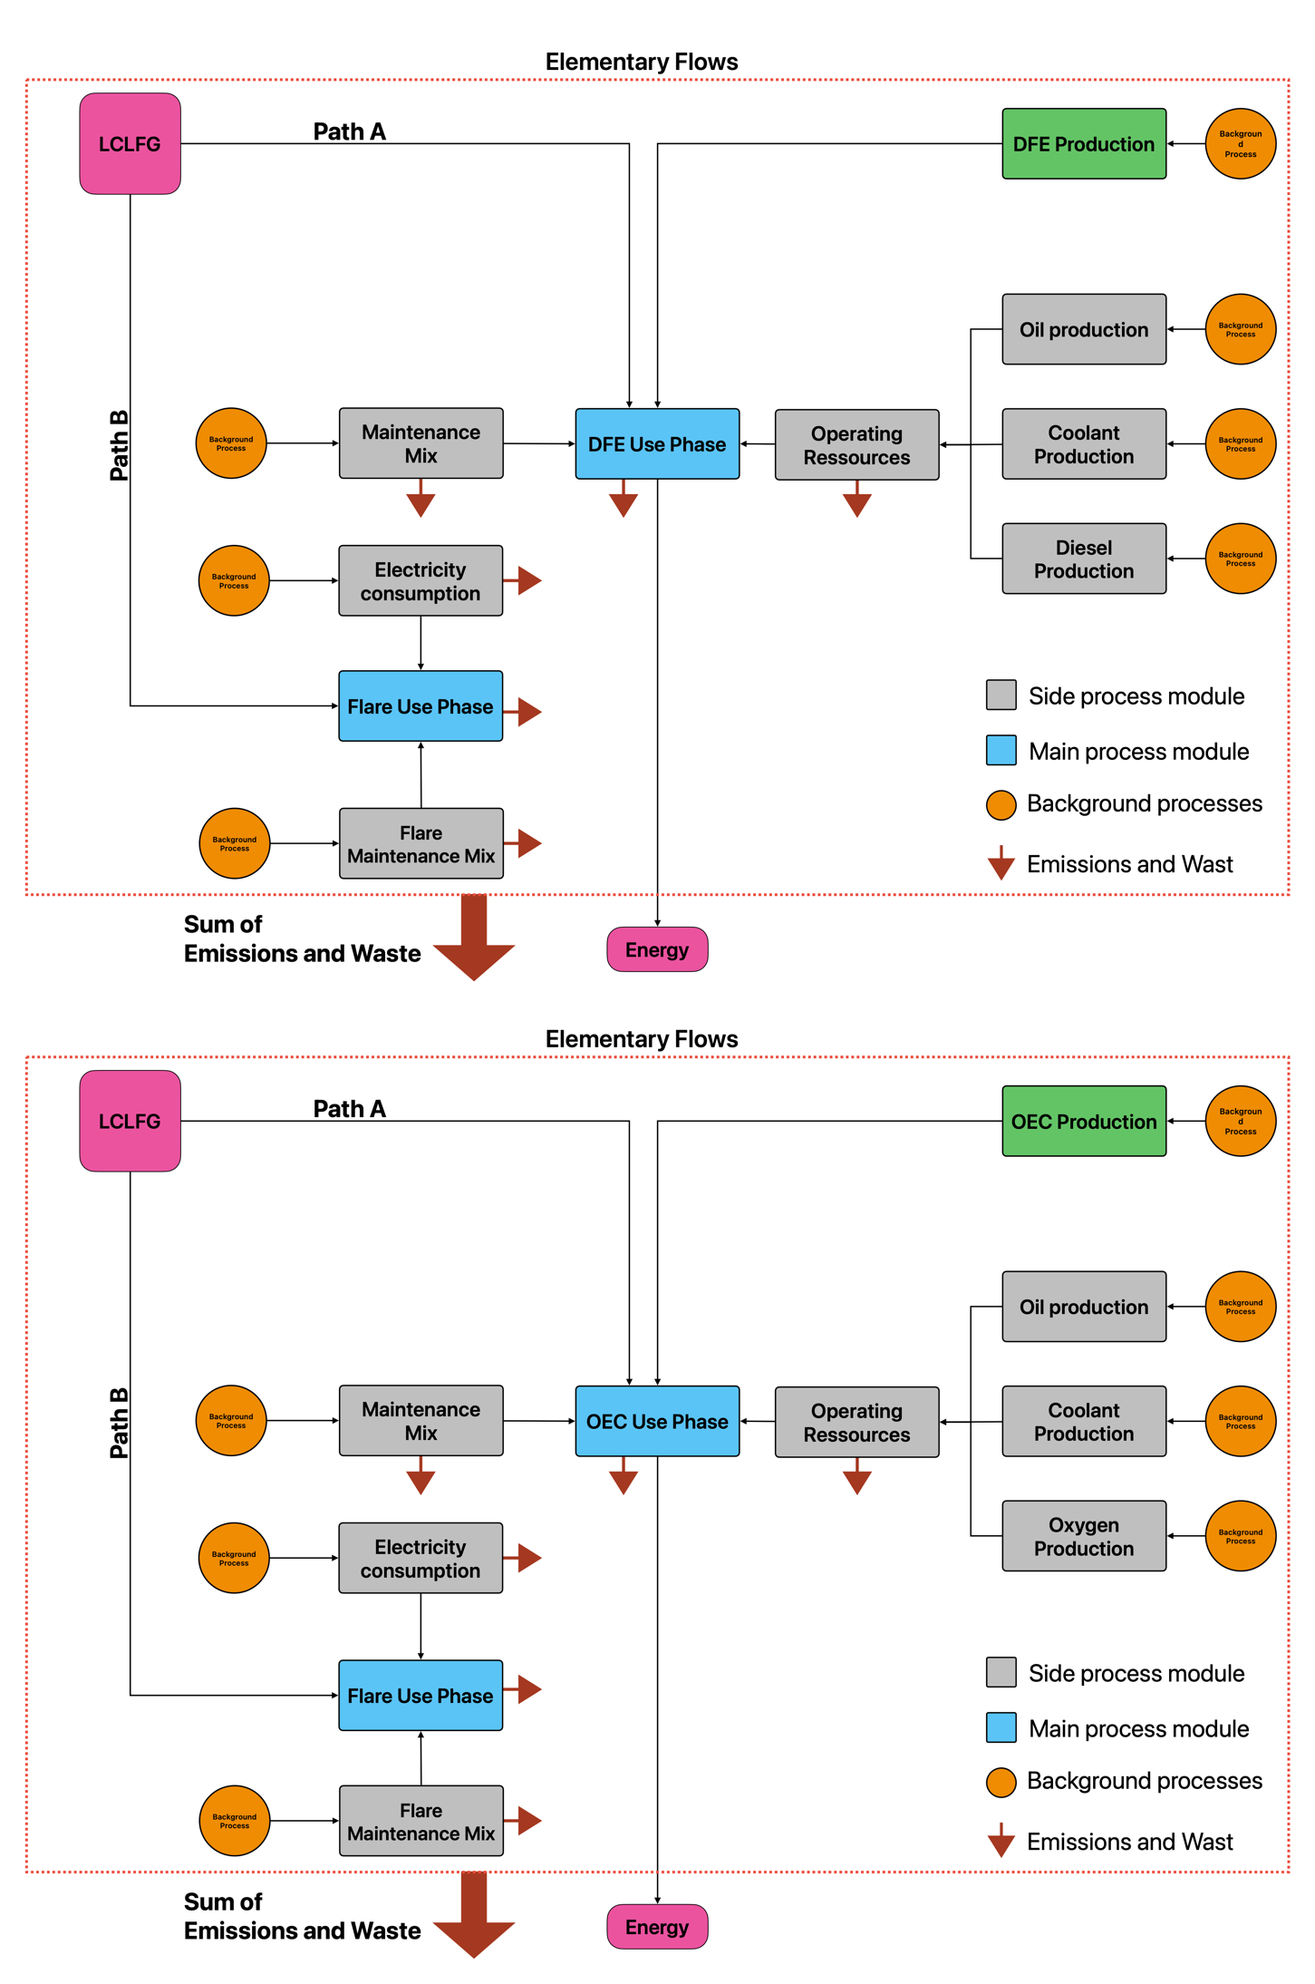

Figure 24: DFE and OEC process system and boundaries

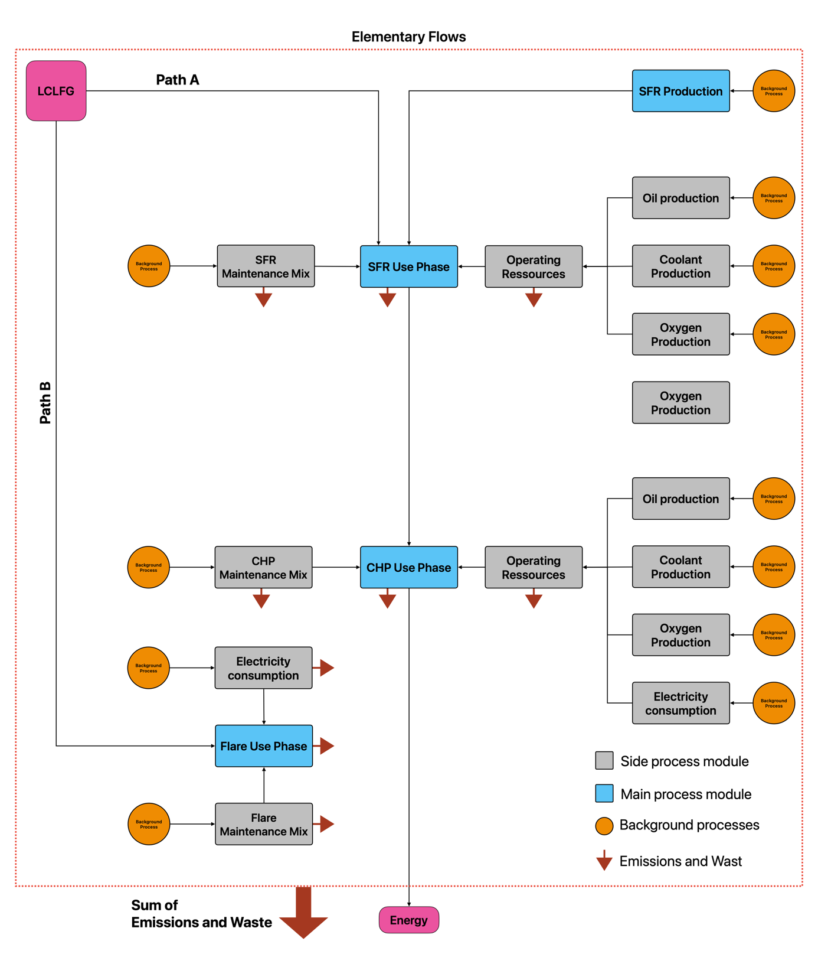

Figure 26: SFR System boundaries

As shown in the system there are different ways of LCLFG processing. If the gas quality allows the processing with the project technology the LCA is calculated for path A. If the gas quality is too poor the LCA considers path B.

It is also visible that the produced energy is outside of the system boundary. The LCA doesn’t consider the produced energy to be reused in the system.

1. **Database, software, and assessment method**

The results of the LCA should be calculated using the ReCiPE 2016 assessment method. The background data is based on the 18 midpoint results and must therefore also be calculated for these.

The open source program OpenLCA is recommended as the software for the LCA. The results can be exported as Excel files and inserted into the corresponding CSV files.

Due to the large amount of data, Ecoinvent is the recommended database to use. Research should be conducted to determine whether the publication of results calculated on the basis of the Ecoinvent database using a university license is legally permissible within the scope of LoCaGas.

1. **Parametric approach to LCA**

Since the LCA tool provides variable input for gas development and the observation period, the LCA results must be scalable accordingly. To achieve this, the process modules shown in the process diagram must be calculated for quantities that can be easily scaled later in the tool.

For oil production, it makes sense to calculate the LCA for 1L of oil, etc.

The situation is slightly different for maintenance. The tool assumes that maintenance must be carried out at various intervals depending on the utilization rate. The process module for maintenance should include a mix of different maintenance elements that occur over the entire lifetime of the respective machine. The proportions of the various maintenance elements must be included in such a way that their frequency is taken into account. The proportion of maintenance required in a year is then calculated as a function of utilization and annual operating time.

The amount of emissions in the tool also depends on the utilization of the machine and thus on the variable input parameters. This means that a reference quantity must also be calculated to determine the environmental impact of the emissions, which can then be easily offset against the emission results from the tool. For example, 1 kg can be used as the quantity.

# Next steps:

The LCA tool is far from complete. Above all, the precise and detailed creation of the various LCA scenarios and the calculation of the reference results based on them, which can be calculated in the tool, must be carried out carefully as the next step.

The development of the code for the web app is largely complete for the implementation of the current concept. If no further fundamental changes are made, the results of future LCAs can be entered into the data frames without having to make changes to the source code.

If fundamental changes are to be made, the code can of course be adapted. Especially when it comes to changing the background data frames, care should always be taken to ensure that these are changed in the corresponding Github repository, as the code accesses these data frames directly.

**The most important next steps:**

1. Data collection for all technologies: Data collection must be completed, particularly with regard to utilization-related parameters. As much data as possible should also be collected for machine production and the production of various operating resources so that as few assumptions as possible need to be made.
2. Implementation of LCAs: Once data collection has been implemented, LCAs must be implemented for all process modules.
3. Updating of data frames: To complete the LCA tool, the calculated results must be entered into the data frames.

**\*Informaiton:** Alle notwendigen Dateien die für die Durchführung der LCAs als auch zur Erstellung der Webapp benötigt werden, sind im entsprechende GitHub Repository hochgeladen.

# Appendix: AI Prompt and Calculation Logic

This is the complete Prompt on which the webapp is based. With normal free versions of models it was not possible to achieve a working version of the webapp by just prompting the complete message. But with a step by step approach and by including reviewing the code over and over again the results were very good.

**Base Prompt:**

**1. Introduction:**

I want to create a web app. The programming languages to be used are JavaScript, HTML, and CSS. Programming will be done in VS Code. Ultimately, 3 programs are to be written. A JavaScript code for the backend and the logic. A CSS code for the style. And the HTML code. All programs should be executable via the HTML code. The code will be stored in a Github repository and launched via Github Pages.

**2. Fundamental Goal:**

I am working on a project in which three technologies for the utilization of low-calorific landfill gas are to be compared with each other on an ecological and economic level. This comparison is to be made based on a number of input parameters, whose values the user can define in the app. Background data is stored which, in combination with the input parameters, forms the basis for the calculations. Three technologies are compared: Dual Fuel Engine (DFE); Spinning Fluids Reactor (SFR); Oxygen Enriched Combustion (OEC). Flaring (Flare) is considered as a reference. The background data includes machine-specific, ecological, economic, and general data. The ecological data was generated from Life Cycle Assessments conducted for various life cycle stages of the different technologies. These essentially relate to the production of the technology, the production and consumption of operating resources during landfill gas utilization, the maintenance of the technology, and the emissions that arise during the utilization of the landfill gas. The results for the ecological analysis are presented in the impact categories of the ReCiPe method. These are shown in the background data. On the economic side, data was stored for the production of the technology and the operating resources, as well as for the performance of maintenance work. Based on this data in combination with the input parameters, the web app should calculate the "Net Present Value" (NVP).

**3. General Functionality of the App**

**3.1 Data Basis**

Attached is a PDF file in which the text data is structured into the blocks CSV1-23. These contain the aforementioned data and were exported from Excel tables. The data from the file should be used for the development of the web app. The individual CSV files are also stored in a Github repository. The web app should access the data via the Github repository. This should allow for future value changes to be automatically adopted in the program code. The links to the individual CSV files in the Github repository are listed below: CSV 1: <https://raw.githubusercontent.com/Svenhardy/Low-Calorific-Landfillgas-Tool/refs/heads/main/CSV%20Files/CSV1.csv> CSV 2: <https://raw.githubusercontent.com/Svenhardy/Low-Calorific-Landfillgas-Tool/refs/heads/main/CSV%20Files/CSV2.csv> CSV3: <https://raw.githubusercontent.com/Svenhardy/Low-Calorific-Landfillgas-Tool/refs/heads/main/CSV%20Files/CSV3%20.csv> CSV4: <https://raw.githubusercontent.com/Svenhardy/Low-Calorific-Landfillgas-Tool/refs/heads/main/CSV%20Files/CSV4.csv> CSV5: <https://raw.githubusercontent.com/Svenhardy/Low-Calorific-Landfillgas-Tool/refs/heads/main/CSV%20Files/CSV5%20.csv> CSV6: <https://raw.githubusercontent.com/Svenhardy/Low-Calorific-Landfillgas-Tool/refs/heads/main/CSV%20Files/CSV6%20.csv> CSV7: <https://raw.githubusercontent.com/Svenhardy/Low-Calorific-Landfillgas-Tool/refs/heads/main/CSV%20Files/CSV7%20.csv> CSV8: <https://raw.githubusercontent.com/Svenhardy/Low-Calorific-Landfillgas-Tool/refs/heads/main/CSV%20Files/CSV8%20.csv> CSV9: <https://raw.githubusercontent.com/Svenhardy/Low-Calorific-Landfillgas-Tool/refs/heads/main/CSV%20Files/CSV9.csv> CSV10: <https://raw.githubusercontent.com/Svenhardy/Low-Calorific-Landfillgas-Tool/refs/heads/main/CSV%20Files/CSV10.csv> CSV11: <https://raw.githubusercontent.com/Svenhardy/Low-Calorific-Landfillgas-Tool/refs/heads/main/CSV%20Files/CSV11.csv>CSV12: <https://raw.githubusercontent.com/Svenhardy/Low-Calorific-Landfillgas-Tool/refs/heads/main/CSV%20Files/CSV12.csv> CSV13: <https://raw.githubusercontent.com/Svenhardy/Low-Calorific-Landfillgas-Tool/refs/heads/main/CSV%20Files/CSV13.csv> CSV14: <https://raw.githubusercontent.com/Svenhardy/Low-Calorific-Landfillgas-Tool/refs/heads/main/CSV%20Files/CSV14.csv> CSV15: <https://raw.githubusercontent.com/Svenhardy/Low-Calorific-Landfillgas-Tool/refs/heads/main/CSV%20Files/CSV15.csv>CSV16: <https://raw.githubusercontent.com/Svenhardy/Low-Calorific-Landfillgas-Tool/refs/heads/main/CSV%20Files/CSV16%20.csv> CSV17: <https://raw.githubusercontent.com/Svenhardy/Low-Calorific-Landfillgas-Tool/refs/heads/main/CSV%20Files/CSV17.csv> CSV18: <https://raw.githubusercontent.com/Svenhardy/Low-Calorific-Landfillgas-Tool/refs/heads/main/CSV%20Files/CSV18%20.csv> CSV19: <https://raw.githubusercontent.com/Svenhardy/Low-Calorific-Landfillgas-Tool/refs/heads/main/CSV%20Files/CSV19.csv> CSV20: <https://raw.githubusercontent.com/Svenhardy/Low-Calorific-Landfillgas-Tool/refs/heads/main/CSV%20Files/CSV20%20.csv> CSV21: <https://raw.githubusercontent.com/Svenhardy/Low-Calorific-Landfillgas-Tool/refs/heads/main/CSV%20Files/CSV21.csv> CSV22: <https://raw.githubusercontent.com/Svenhardy/Low-Calorific-Landfillgas-Tool/refs/heads/main/CSV%20Files/CSV22.csv>CSV23: <https://raw.githubusercontent.com/Svenhardy/Low-Calorific-Landfillgas-Tool/refs/heads/main/CSV%20Files/CSV23.csv>

**3.2 Specification of Parameters:**

The calculation logic, explained later, uses parameterized formulas. The parameters are divided into four categories:

1. Parameters from CSV files are always used in a formula with the name of the column header and an explanation in parentheses indicating which CSV file they are to be taken from.
2. There are input parameters A-M: These are named A-M in the formulas.
3. Types of Result Parameters:
   * **IR:** Intermediate Results general and Dual Fuel Engine
   * **IRO:** Intermediate Results for Oxygen Enrichment
   * **IRS:** Intermediate Results for SFR and CHP
   * **IRF:** Intermediate Results for Flare
   * **O:** Output Parameters general and Dual Fuel
   * **OO:** Output Parameters for Oxygen Enrichment
   * **OS:** Output Parameters for SFR and CHP
   * **OF:** Output Parameters for Flare
4. Other Parameters:
   * **V:** Values from CSV file for Dual Fuel
   * **VO:** Values from CSV file for OEC
   * **VS:** Values from CSV file for SFR and CHP

**3.2 Specification of the General Calculation Logic:**

This is a general specification of the calculation logic. The actual calculation considers significantly more parameters. This specification is intended only for clarification and understanding. The results (almost always) represent result series that contain a value or a result for each year of the consideration period.

The calculation proceeds in the following steps:

1. **Calculation of the technology-specific results.** This follows the same principle for all technologies: 1.1 Based on the general calculations, it is calculated for each machine size and its specific restrictions - which are described in the CSV files - whether it can utilize the available gas input in a specific year of the consideration period. 1.2 Subsequently, it is determined which machine size utilizes the most gas over the entire consideration period. All subsequent calculations are performed for this specific machine size. 1.3 In the next step, it is calculated how many resources the machine consumes and how many emissions are emitted during its operating time in each year of the consideration period. This resource consumption depends on the machine utilization, which in turn depends on the energy content of the landfill gas. The program compares the machine utilization for each year and determines the resource consumption or the emissions at this specific utilization. The information is stored in the CSV data. Based on this, the specific resource consumption and the emission quantity can be calculated for each year of the consideration period. 1.4 It is also calculated how much energy is produced in each year of the consideration period. Machine-specific data from the CSV data is also used for this. 1.5 For the years in which the specific machine cannot be used due to the quality of the landfill gas and the machine-specific restrictions, it is assumed that the landfill gas is flared. The resources expended and the emission quantity for this are also calculated. 1.6 In the next step, the ecological results are calculated. In the CSV files, environmental impacts in various impact categories are recorded for different general, emission, and resource-specific categories. These always refer to a reference flow. For example, 1L engine oil or 1L diesel. These results are offset against the machine-specific resource consumption. In this way, the result for the environmental impact category can be calculated for each year and each category. 1.7 In the final calculation step, the economic results are calculated. For this, the intermediate results for the machine-specific resource consumption are also used. These are then offset against the economic data from the CSV files. Finally, the Net Present Value is calculated based on the results.

**4. App Structure:**

The web app is divided into several tabs. The first tab is used for entering the input parameters. This is followed by four more tabs that present the results. They are divided into the following areas:

* Gas Development
* General Results
* Ecological Results
* Economic Results

Another tab is used to display intermediate results, which are intended to serve as verification of the calculation steps. The exact design of the tabs for results and intermediate results is specified elsewhere.

**5. Presentation of the Input Parameters:**

The tab for the input data should be designed as follows: There are three categories of input fields that are presented minimally in three rows. The rows are numbered 1-3. The numbers are displayed in color-filled circles. Row 1 is green, Row 2 is orange, and Row 3 is gray.

In the first row are the gas-specific input categories. A short explanatory text is listed above the row: “ Please indicate the quantity and quality of the LFG output of your landfill as well as the time horizon over which you intend to use the gas. The tool will calculate the gas development over this time period automatically or you can enter it manually .”

* **A:** Gas quantity at the beginning [m³/h]
* **B:** Methane content at the beginning [%]
* **C:** Consideration period [Years]
* **k-Value:** K-value according to the Clean Air Act (CAA)

Next to the fields "Gas quantity at the beginning [m³/h]" and "Methane content at the beginning [%]", the option **"manual input"** can be clicked. If this is done, a number of fields corresponding to the numerical value in the input field "Consideration period [Years]" will open. The corresponding value for the methane content and the gas quantity for each year of the consideration period can then be entered manually into these fields.

The following input fields are available in the second row:

* **D:** Project country (Dropdown selection: Germany; Sweden; Poland; Lithuania)
* **E:** Electrical energy price [€/kWh el.]
* **F:** Thermal energy price [€/kWh th.]
* **G:** Depreciation period [Years]
* **H:** Tax rate [%]
* **I:** Discount rate [%/Year]

For each of the input fields D, E, F, G, H, I, the option **"manual input"** can be selected. If this option is selected, a custom value can be entered into the input field. If the option "manual input" is not selected, the input fields E, F, G, and H are automatically filled with a country-specific predefined value from the background data, and manual input is not possible. The program accesses the **"CSV1"** dataset for this. In the CSV file, the corresponding input categories are listed in columns with the identical wording, and the country-specific values are listed in the rows below. If **"manual input"** is not selected for input field **I (Discount rate)**, the program always sets the value to **4%**.

The following input parameters are available in the third row:

* **J:** Energy source (Dropdown selection: Renewable; Country-specific)
* **K:** Annual machine operating hours [h/a]
* **L:** Type of supplementary fuel (Dropdown selection: Diesel, Pilot Fuel)
* **M:** CHP available (Dropdown selection: Yes; No)

**6. General Background Calculations**

The program performs general calculations in the background, which are used as the basis for the technology-specific calculations.

**6.1 Gas Development:**

Methane content and volumetric flow of the gas change over time. Two equations are introduced for this, both based on the input parameters A, B, C, and the input k-value.

* **IR1: Methane content in year n [%]** = (Methane content in year n - 1 * e^(-k-Value * n)) / ((Methane content in year n - 1 * e^(-k-Value * n)) + (1 - Methane content in year n – 1))
* **IR2: Volumetric flow in year n [m³/h]** = Volumetric flow in year n - 1 * e^(k-Value * n)

The calculation is performed for a number of steps **n = Consideration period**. For Year 1, the values of input parameters A and B are used, and no calculation is performed. For all subsequent years, the values from the previous year n-1 are used.

**6.2 Energy Content**

Based on the results IR1 and IR2, the energy content of the gas is calculated in each year **n** of the consideration period. For this, the calorific value for methane (CH4) is retrieved from the dataset **"CSV2"**, and the value for input parameter **K (Annual machine operating hours)** is used, and the following calculation is performed:

* **IR3: Energy content of the landfill gas in year n [kW]** = IR1 * IR2 * Calorific Value CH4(CSV2) * K

**7. Background Calculations for the Dual Fuel Engine:**

In addition to the general calculations, technology-specific calculations are performed for each technology. First, the calculations for DFE are executed.

**7.1 Selection of the Optimal Machine Size**

A total of three different DFE machine sizes with various limitations are defined in the background data. The program should automatically select the machine size that utilizes the largest amount of landfill gas over the entire consideration period. The program proceeds as follows:

**7.11 Calculation of the Calorific Value of Diesel or Pilot Fuel and Landfill Gas**

Since Diesel or a Pilot Fuel is also used for combustion with DFE, the total calorific value is calculated as follows. If "Diesel" was selected under Input **L (Type of supplementary fuel)**, the value for **"Calorific Value Diesel"** is retrieved from the file **"CSV2"**; if "Pilot Fuel" was selected, the value for **"Calorific Value Pilot Fuel"** is selected. The values for the column **"Fuel Consumption"** for the respective **"Engine Size"** are retrieved from the dataset **"CSV3"**. Subsequently, the following calculation is performed for each **"Engine Size"**:

* **IR4: Energy content of landfill gas and diesel in year n [kW]** = IR3 + Calorific Value Diesel(CSV2) * K * Fuel Consumption(CSV3)

**7.12 Calculation of the Energy Utilization for Each Engine Size**

Next, the energy utilization of each engine size is calculated. For this, the values in the column **"Engine Efficiency"** are retrieved from **"CSV3"** for each **"Engine Size"**. The following calculation is then performed for each engine size and each year of the consideration period:

* **IR5: Energy Utilization in year n [KW el.]** = (IR4 / k) * Engine Efficency el.(CSV3)

Subsequently, the relative utilization of the different engines is calculated. For this, the value for **"Engine Size"** is retrieved from **"CSV3"**. The following calculation is then performed for each engine size and each year of the consideration period:

* **IR6: Relative Utilization in year n [%]** = (IR5 / Engine Size(CSV3)) * 100

**7.13 Check if Engine Can Be Used**

In the next step, it is checked for each DFE engine size whether the engine can be used in year **n** of the consideration period. For this, the values for the **"Max. volume flow"**, the **"min volume flow"**, and the **"min. Engine Load"** are retrieved from the dataset **"CSV3"** for each DFE engine size. Based on these values, 2 ranges are defined for each engine.

* **Range 1:** Max. Volume Flow(CSV3) – Min. Volume Flow(CSV3)
* **Range 2:** Min, Engine Load(CSV3) – 100%

Subsequently, for each year and each engine, it is checked whether IR2 is within or outside Range 1 and whether IR 6 is within or outside Range 2. The following If-Cause is performed for the calculation of IR7 for each engine size and each year of the consideration period:

* **If IR2 is outside Range 1 or if IR6 is outside Range 2, then IR7=0, otherwise IR7=1.**

**7.14 Usable Gas Quantity and Engine Selection**

Finally, the usable gas quantity is calculated for each engine. For this, the following calculation is performed for each engine over each year of the consideration period:

* **IR8: Total Quantity of Processed Gas** = Sum(IR7 * IR2 * K)

The engine size for which the highest value results is used in the subsequent calculations.

* **O1: Correct Engine Size** = choose max. in IR8

If the result for IR8 is = 0 for all engine sizes, an error message is displayed:

* **E1:** “For one or more utilization technologies, no suitable engine size is available. Please adjust the input values A and B.”

**7.15 Gas Quantity Flared**

The quantity of flared gas is calculated based on the result value for IR7 as follows.

* **IR9: Quantity of Gas Flared in Year n:** If IR7 = 0, then IR9 = IR2 * K, otherwise IR9 = 0

**7.2 Engine-Specific and Utilization-Dependent Background Calculations**

In the next step, specific calculations are performed for the engine size selected under 7.1, which vary depending on engine utilization.

**7.21 Selection of the Correct Values from the Background Data**

In a first step, the correct values for the engine selected under 7.14 and for each year of the consideration period are selected for all categories dependent on engine utilization. The engine-dependent data is stored in the **"CSV4"** dataset. Based on the result **IR6 (Relative Utilization in year n)** for the correct engine size **O1**, the correct values from the columns **"Oil Change"**, **"Maintenance Period"**, **"Coolant Change"**, **"Fuel Consumption Factor"**, and **"Electricity consumption factor"** are to be selected from the **"CSV4"** dataset. For this, the annual value from IR6 for O1 is compared with the values from column 1 **(Engine Load)** in **"CSV4"**. For the named categories, the value from the row closest to the engine utilization in the specific year is selected. The following value lists result:

* **V1:** Utilization-dependent fuel factor for year n
* **V2:** Utilization-dependent electricity factor for year n
* **V3:** Utilization-dependent maintenance period for year n
* **V4:** Utilization-dependent coolant change period for year n
* **V5:** Utilization-dependent oil change period for year n

**7.22 Calculation of the Annual Utilization-Dependent Values**

In the next step, the annual utilization-dependent values for each of the categories listed above are calculated. The following values for the previously selected engine size **O1** are retrieved from the file **"CSV3"**: **"Fuel Consumption"**, **"Electricity consumption"**, **"Coolant Tank Volume"**, **"Oil Tank volume"**.

The following calculations are performed:

* **IR10: Diesel consumption year n [L]** = V1 * K * Diesel Consumption(CSV3) * IR7
* **IR11: Electricity consumption year n [kWh]** = V2 * K * Electricity consumption(CSV3) * IR7
* **IR12: Maintenance frequency year n** = K / V3 * IR7
* **IR13: Coolant consumption year n [L]** = (K / V4) * Coolant Tank Volume(CSV3) * IR7
* **IR14: Oil consumption year n [L]** = (K / V5) * Oil Tank Volume(CSV3) * IR7

**7.3 Calculation of Engine Emissions:**

Engine emissions are also dependent on engine utilization. The data is stored in the **"CSV5"** dataset. Based on the result **IR6 (Relative Utilization in year n)** for the correct engine size **O1**, the correct values from the columns **"Carbon Monoxide"**, **"Nitrogene Oxide"**, **"Formaldehyd"**, **"Methane Slop"**, **"Particulate Matter"**, **"Sulfur Dioxide"** and **"Ammonia"** are to be selected from the **"CSV5"** dataset. For this, the annual value from IR6 for O1 is compared with the values from column 1 **(Engine Load)** in **"CSV5"**. For the named categories, the value from the row closest to the engine utilization in the specific year is selected. The following value lists result:

* **V6:** Utilization-dependent value for Carbon Monoxide
* **V7:** Utilization-dependent value for Nitrogene Oxide
* **V8:** Utilization-dependent value for Formaldehyd
* **V9:** Utilization-dependent value for Methane Slop
* **V10:** Utilization-dependent value for Particulate Matter
* **V11:** Utilization-dependent value for Sulfur Dioxide
* **V12:** Utilization-dependent value for Ammonia

In the next step, the annual utilization-dependent values for each of the emissions listed above are calculated. The calculation is represented in a shortened form below, but should be carried out for all values V6-12.

* **IR15: Amount of Emission X in year n** = Emission Vx * IR2 * IR7 * K

**7.4 Utilization-Independent Engine-Specific Background Calculations**

In the next step, the utilization-independent intermediate results are calculated.

**7.41 Calculation of the Generated Energy Quantity**

First, the thermal and electrical energy revenues are calculated. For this, the values for **"Engine efficency el."** and **"Engine efficency th."** are selected from the background dataset **"CSV3"** for the correct engine size **O1** selected under 7.14. Subsequently, the following calculations are performed:

* **IR16: Th. Energy produced in year n** = Engine efficiency th. * IR4 * IR7
* **IR17: El. Energy produced in year n** = Engine efficiency el. * IR4 * IR7

**7.42 Calculation of Flare Impacts:**

In the next step, the engine-specific intermediate results for flare operation are calculated for each year of the consideration period. In a first step, the operating time of the flare in the respective year **n** of the consideration period is determined using the following relationship.

* **IR18: Opr. h Flare in year n:** If IR7 = 0, then IR18 = K, otherwise IR18 = 0

Based on these values, the flare-specific operating expenditures can be calculated. For this, the values for **"Maintenance Period"** and **"Electricity Consumption"** are retrieved from the background file **"CSV6"**. The following calculations are performed:

* **IR19: Flare maintenance frequency in year n** = IR18 / Maintenance Period
* **IR20: Flare electricity use in year n** = IR18 * Electricity Consumption

In the next step, the flare emissions are calculated. For this, the values for the listed emissions are retrieved from the **"CSV7"** dataset. In the formula below, these are summarized as **Emission X** as an example. Subsequently, the values for the years in which IR7=0 are multiplied by the volumetric flow IR2.

* **IR21: Flare Emission X in year n:** If IR7=0, then IR21 = Emission X * IR2*K, otherwise IR21=0

**7.5 Final Ecological Results:**

In the next step, the program calculates the final results in the different impact categories and for the different influence factors calculated previously.

**7.51 Calculation of Engine Production-Related Environmental Impacts**

First, the environmental impacts due to engine production are calculated. For this, the specific value for **"Production Factor"** for the correct engine size selected under 7.14 is retrieved from the **"CSV3"** dataset. Furthermore, the values for each **Impact Category X** for the row **"Engine Production"** are selected from the **"CSV8"** dataset.

* **O2: Engine Production Impact in Impact Category X in year n** = Production Factor * Engine Production in Impact Category X

**7.52 Calculation of Fuel-Related Environmental Impacts**

If "Diesel" was selected under Input **L**, the values for each **Impact Category X** for the row **"Diesel Production"** are retrieved from the **"CSV8"** dataset, and the following calculation is performed:

* **O3: Fuel Production Impact in Impact Category X in year n** = IR10 * Diesel Production in Impact Category X

If "Pilot Fuel" was selected under Input **L**, the values for each **Impact Category X** for the row **Pilot Fuel Production** are retrieved from the **"CSV8"** dataset, and the following calculation is performed:

* **O3: Fuel Production Impact in Impact Category X in year n** = IR10 * Pilot Fuel Production in Impact Category X

**7.53 Calculation of Operating Resources-Related Environmental Impacts**

In the next calculation step, the values for each **Impact Category X** for the rows **"Maintenance"**, **"Oil production"**, and **"coolant production"** are retrieved from the **"CSV8"** dataset, and the following calculations are performed:

* **O4: Maintenance Impact in Impact Category X in year n** = IR12 * Maintenance in Impact Category X
* **O5: Oil Impact in Impact Category X in year n** = IR14 * Oil production in Impact Category X
* **O6: Coolant Impact in Impact Category X in year n** = IR13 * Coolant production in Impact Category X

**7.54 Calculation of Emission-Related Environmental Impacts**

In the next calculation step, the values for each **Impact Category X** for the respective **Emission X** are retrieved from the **"CSV9"** dataset. The respective value for **Emission X** in **Impact Category X** is multiplied by the correct value of the respective **Emission X**, which are summarized under IR15.

* **O7: Emission Impact in Impact Category X in year n** = IR15 (for Emissoin X) * Emission Impact in Impact Category X
* **O7.1: Sum of Emission Impacts in Impact Category X in year n** = Sum(Emission X in Impact Category X)

**7.55 Calculation of Energy-Related Environmental Impacts**

In the next calculation step, data from the **"CSV10"** dataset is accessed. This dataset shows the environmental impacts for the provision of energy in different countries, as well as the environmental impacts for the provision of fully renewable energy. Depending on which country was selected under Input **D**, the values for each **Impact Category X** for the corresponding country are retrieved from **"CSV10"**. If **"Renewable"** was selected under Input **J**, the values for each **Impact Category X** from **CSV 10** that are in the row **"Renewable"** are selected, regardless of Input **D**.

The following calculation is performed:

* **O8: Engine Energy Impact in Impact Category X in year n** = IR11 * Energy specific Impact in Impact Category X
* **O9: Flare Energy Impact in Impact Category X in year n** = IR20 * Energy specific Impact in Impact Category X

**7.56 Calculation of Flare-Related Environmental Impacts**

In the next calculation step, the values for each **Impact Category X** for the row **"Maintenance"** are retrieved from the **"CSV11"** dataset.

The following calculation is performed:

* **O10: Flare Maintenance Impact in Impact Category X in year n** = IR19 * Maintenance in Impact Category X

**7.57 Calculation of Flare-Related Environmental Impacts**

In the next calculation step, the values for each **Impact Category X** for the respective **Emission X** are retrieved from the **"CSV9"** dataset. The respective value for **Emission X** in **Impact Category X** is multiplied by the correct value of the respective **Emission X**, which are summarized under IR21.

* **O11: Flare Emission Impact in Impact Category X in year n** = IR21 (for Emissoin X) * Emission Impact in Impact Category X
* **O11.1: Sum of Emission Impacts in Impact Category X in year n** = Sum(Emission X in Impact Category X)

**7.58 Environmental Impacts by Category**

The environmental impacts are summarized in the following categories:

* **O12: Environmental Impacts from Operating Resources in year n** = O8 + O6 + O5
* **O13: Environmental Impacts from Flare in year n** = O9 + O10 + O11.1
* **O14: Sum of Environmental Impacts in Impact Category X in year n** = O12 + O13 + O7.1 + O4 + O3 + O2

**7.6 Final Economic Results:**

**7.61 Calculation of Energy Revenue**

The revenues from the generated energy are calculated based on the Inputs **E** and **F** as follows.

* **O15: Electric energy revenue in year n** = IR17 * E
* **O15: Thermal energy revenue in year n** = IR16 * F

**7.61 Calculation of the Costs for Flare Operation**

For the calculation of the costs for flare operation, the Input **D** dependent, country-specific value for **"Maintenance Flare"** is selected from the dataset **"CSV 1"**, and the following calculation is performed.

* **O16: Flare maintenance costs in year n** = IR19 * Maintenance Flare(CSV1)

The following calculation is performed for the flare's energy consumption:

* **O17: Flare electricity costs in year n** = IR20 * E

**7.61 Calculation of the Costs for Engine Operation**

The following calculation is performed for the engine's energy consumption:

* **O18: Dual Fuel electricity costs in year n** = IR11 * E

For the calculation of the costs for engine maintenance, the value for **"Maintenance"** is selected from the dataset **"CSV12"**, and the following calculation is performed:

* **O19: Dual Fuel maintenance costs in year n** = IR12 * Maintenance(CSV12)

For the calculation of the costs for oil consumption, the value for **"Oil"** is selected from the dataset **"CSV12"**, and the following calculation is performed:

* **O20: Dual Fuel oil costs in year n** = IR14 * Oil(CSV12)

For the calculation of the costs for coolant consumption, the value for **"Coolant"** is selected from the dataset **"CSV12"**, and the following calculation is performed:

* **O21: Dual Fuel coolant costs in year n** = IR13 * Coolant(CSV12)

**7.62 Calculation of the Costs for Engine Fuel Consumption**

For the calculation of the costs for engine fuel consumption, the value for **"Diesel"** is selected from the dataset **"CSV12"**, and the following calculation is performed:

* **O22: Dual Fuel Fuel costs in year n** = IR10 * Diesel(CSV12)

**7.63 Calculation of the Costs for Engine Acquisition**

For the calculation of the costs for engine acquisition, the correct **O1**-dependent engine-specific value for **"Price Factor"**is retrieved from the **"CSV3"** dataset. The value for **"Dual Fuel Engine Cost"** is retrieved from the **"CSV12"** dataset, and the following calculation is performed:

* **O23: Dual Fuel Acquisition costs** = Price Factor * Dual Fuel Engine Cost(CSV12)

**7.64 Calculation of the Cashflow**

The following value is obtained for the total costs:

* **O24: Cashflow in year n** = O15 + O16 + O17 + O18 + O19 + O20 + O21 + O22

**7.65 Calculation of the Net Present Value (NVP)**

For the calculation of the NVP, the value for Input **I (Discount rate)** is used.

* **O25: NVP** = - O23 + sum (O24 / ((1 + I) ^ n))

The sum is calculated for **n = 1** to **G (Depreciation period)**.

**8. Background Calculations for the Oxygen Enriched Combustion Engine (OEC)**

The calculations for the OEC engine follow the same steps as the DFE engine. If necessary, different CSV data sets are used, which are specified below.

**8.1 Selection of the Optimal Machine Size**

It is determined which machine size utilizes the largest amount of gas over the entire consideration period. There are a total of three different OEC machine sizes with various limitations defined in the background data.

**8.11 Calculation of the Calorific Value of Oxygen and Landfill Gas**

For OEC, oxygen is used, the consumption of which is dependent on the machine size. The value for **"Oxygen"** for the respective **"Engine Size"** is retrieved from the **"CSV13"** dataset. Subsequently, the following calculation is performed for each **"Engine Size"**:

* **IRO4: Oxygen consumption in year n** = (IR3 * Oxygen(CSV13)) / (K * 24 * 365)
* **IRO5: Energy Utilization in year n [KW el.]** = (IR3 - IRO4) * Engine Efficency el.(CSV13)
* **IRO6: Relative Utilization in year n [%]** = (IRO5 / Engine Size(CSV13)) * 100

Subsequently, it is checked whether the engine can be used. The logic corresponds to 7.13.

* **IRO7:** If IR2 is outside Range 1 or if IRO6 is outside Range 2, then IRO7=0, otherwise IRO7=1.

Finally, the usable gas quantity is calculated for each engine.

* **IRO8: Total Quantity of Processed Gas** = Sum(IRO7 * IR2 * K)

The engine size for which the highest value results is used in the subsequent calculations.

* **OO1: Correct Engine Size** = choose max. in IRO8

**8.2 Engine-Specific and Utilization-Dependent Background Calculations**

The engine-specific calculations are performed for the selected engine size.

**8.21 Selection of the Correct Values from the Background Data**

The engine-dependent data is stored in the **"CSV14"** dataset. Based on the result **IRO6 (Relative Utilization in year n)**for the correct engine size **OO1**, the correct values from the columns **"Oil Change"**, **"Maintenance Period"**, **"Coolant Change"**, **"Fuel Consumption Factor"**, and **"Electricity consumption factor"** are to be selected from the **"CSV14"**dataset. For this, the annual value from IRO6 for OO1 is compared with the values from column 1 **(Engine Load)** in **"CSV14"**. For the named categories, the value from the row closest to the engine utilization in the specific year is selected. The following value lists result:

* **VO1:** Utilization-dependent fuel factor for year n
* **VO2:** Utilization-dependent electricity factor for year n
* **VO3:** Utilization-dependent maintenance period for year n
* **VO4:** Utilization-dependent coolant change period for year n
* **VO5:** Utilization-dependent oil change period for year n

**8.22 Calculation of the Annual Utilization-Dependent Values**

The following values for the previously selected engine size **OO1** are retrieved from the file **"CSV13"**: **"Fuel Consumption"**, **"Electricity consumption"**, **"Coolant Tank Volume"**, **"Oil Tank volume"**.

The following calculations are performed:

* **IRO9: Oxygen consumption year n [L]** = IRO4 * IRO7
* **IRO10: Electricity consumption year n [kWh]** = VO2 * K * Electricity consumption(CSV13) * IRO7
* **IRO11: Maintenance frequency year n** = K / VO3 * IRO7
* **IRO12: Coolant consumption year n [L]** = (K / VO4) * Coolant Tank Volume(CSV13) * IRO7
* **IRO13: Oil consumption year n [L]** = (K / VO5) * Oil Tank Volume(CSV13) * IRO7

**8.3 Calculation of Engine Emissions:**

The data is stored in the **"CSV15"** dataset. Based on the result **IRO6 (Relative Utilization in year n)** for the correct engine size **OO1**, the correct values from the columns **"Carbon Monoxide"**, **"Nitrogene Oxide"**, **"Formaldehyd"**, **"Methane Slop"**, **"Particulate Matter"**, **"Sulfur Dioxide"** and **"Ammonia"** are to be selected from the **"CSV15"**dataset. The calculation is represented in a shortened form below, but should be carried out for all values V6-12.

* **IRO14: Amount of Emission X in year n** = Emission VO x * IR2 * IRO7 * K

**8.4 Utilization-Independent Engine-Specific Background Calculations**

**8.41 Calculation of the Generated Energy Quantity**

The thermal and electrical energy revenues are calculated.

* **IRO15: Th. Energy produced in year n** = Engine efficiency th. * IR3 * IRO7
* **IRO16: El. Energy produced in year n** = Engine efficiency el. * IR3 * IRO7

**8.42 Calculation of Flare Impacts:**

The operating time of the flare is determined using the following relationship.

* **IRO17: Opr. h Flare in year n:** If IRO7 = 0, then IRO17 = K, otherwise IRO17 = 0

Based on these values, the flare-specific operating expenditures can be calculated. The values for **"Maintenance Period"**and **"Electricity Consumption"** are retrieved from the background file **"CSV6"**.

* **IRO18: Flare maintenance frequency in year n** = IRO17 / Maintenance Period(CSV6)
* **IRO19: Flare electricity use in year n** = IRO17 * Electricity Consumption(CSV6)

The flare emissions are calculated. The values for the listed emissions are retrieved from the **"CSV7"** dataset.

* **IRO20: Flare Emission X in year n:** If IRO7=0, then IRO20 = Emission X(CSV7) * IR2*K, otherwise IRO20=0

**8.5 Final Ecological Results:**

**8.51 Calculation of Engine Production-Related Environmental Impacts**

The value for **"Production Factor"** for the correct engine size is retrieved from the **"CSV13"** dataset. The values for each **Impact Category X** for the row **"Engine Production"** are selected from the **"CSV16"** dataset.

* **OO2: Engine Production Impact in Impact Category X in year n** = Production Factor(CSV13) * Engine Production in Impact Category X(CSV16)

**8.52 Calculation of Fuel-Related Environmental Impacts**

The values for each **Impact Category X** for the row **"Oxygen Production"** are retrieved from the **"CSV16"** dataset.

* **OO3: Oxygen Production Impact in Impact Category X in year n** = IRO9 * Oxygen Production in Impact Category X(CSV16)

**8.53 Calculation of Operating Resources-Related Environmental Impacts**

The values for each **Impact Category X** for the rows **"Maintenance"**, **"Oil production"**, and **"coolant production"**are retrieved from the **"CSV16"** dataset.

* **OO4: Maintenance Impact in Impact Category X in year n** = IRO11 * Maintenance in Impact Category X(CSV16)
* **OO5: Oil Impact in Impact Category X in year n** = IRO13 * Oil production in Impact Category X(CSV16)
* **OO6: Coolant Impact in Impact Category X in year n** = IRO12 * Coolant production in Impact Category X(CSV16)

**8.54 Calculation of Emission-Related Environmental Impacts**

The values for each **Impact Category X** for the respective **Emission X** are retrieved from the **"CSV9"** dataset.

* **OO7: Emission Impact in Impact Category X in year n** = IRO14 (for Emissoin X) * Emission Impact in Impact Category X(CSV9)
* **OO7.1: Sum of Emission Impacts in Impact Category X in year n** = Sum(Emission X in Impact Category X(OO7))

**8.55 Calculation of Energy-Related Environmental Impacts**

Data from the **"CSV10"** dataset is accessed.

* **OO8: Engine Energy Impact in Impact Category X in year n** = IRO10 * Energy specific Impact in Impact Category X(CSV10)
* **OO9: Flare Energy Impact in Impact Category X in year n** = IRO19 * Energy specific Impact in Impact Category X(CSV10)

**8.56 Calculation of Flare-Related Environmental Impacts**

The values for each **Impact Category X** for the row **"Maintenance"** are retrieved from the **"CSV11"** dataset.

* **OO10: Flare Maintenance Impact in Impact Category X in year n** = IRO18 * Maintenance in Impact Category X(CSV11)

**8.57 Calculation of Flare-Related Environmental Impacts**

The values for each **Impact Category X** for the respective **Emission X** are retrieved from the **"CSV9"** dataset.

* **OO11: Flare Emission Impact in Impact Category X in year n** = IRO20 (for Emissoin X) * Emission Impact in Impact Category X(CSV9)
* **OO11.1: Sum of Emission Impacts in Impact Category X in year n** = Sum(Emission X in Impact Category X(OO11))

**8.58 Environmental Impacts by Category**

The environmental impacts are summarized in the following categories:

* **OO12: Environmental Impacts from Operating Resources in year n** = OO8 + OO6 + OO5
* **OO13: Environmental Impacts from Flare in year n** = OO9 + OO10 + OO11.1
* **OO14: Sum of Environmental Impacts in Impact Category X in year n** = OO12 + OO13 + OO7.1 + OO4 + OO3 + OO2

**8.6 Final Economic Results:**

**8.61 Calculation of Energy Revenue**

* **OO14: Electric energy revenue in year n** = IRO16 * E
* **OO15: Thermal energy revenue in year n** = IRO15 * F

**8.61 Calculation of the Costs for Flare Operation**

The Input **D** dependent, country-specific value for **"Maintenance Flare"** is selected from the dataset **"CSV 1"**.

* **OO16: Flare maintenance costs in year n** = IRO18 * Maintenance Flare(CSV1)
* **OO17: Flare electricity costs in year n** = IRO19 * E

**8.61 Calculation of the Costs for Engine Operation**

* **OO18: OEC electricity costs in year n** = IRO10 * E
* **OO19: OEC maintenance costs in year n** = IRO11 * Maintenance(CSV12)
* **OO20: OEC oil costs in year n** = IRO13 * Oil(CSV12)
* **OO21: OEC coolant costs in year n** = IRO12 * Coolant(CSV12)

**8.62 Calculation of the Costs for Engine Oxygen Consumption**

The value for **"Oxygen"** is retrieved from the **"CSV12"** dataset.

* **OO22: OEC Fuel costs in year n** = IRO9 * Oxygen(CSV12)

**8.63 Calculation of the Costs for Engine Acquisition**

The correct **O1**-dependent engine-specific value for **"Price Factor"** is retrieved from the **"CSV13"** dataset. The value for **"Oxygen Enrichment Engine Cost"** is retrieved from the **"CSV12"** dataset.

* **OO23: OEC Acquisition costs** = Price Factor * Oxygen Enrichment Engine Cost(CSV12)

**8.64 Calculation of the Cashflow**

* **OO24: Cashflow in year n** = OO15 + OO16 + OO17 + OO18 + OO19 + OO20 + OO21 + OO22

**8.65 Calculation of the Net Present Value (NVP)**

* **OO25: NVP** = - OO23 + sum (OO24 / ((1 + I) ^ n))

The sum is calculated for **n = 1** to **G (Depreciation period)**.

**9. Background Calculations for the Spinning Fluids Reactor (SFR)**

The calculations for the SFR follow the same principles as DFE and OEC.

**9.1 Selection of the Optimal Machine Size**

It is determined which machine size utilizes the largest amount of gas over the entire consideration period. There are a total of three different SFR machine sizes with various limitations defined in the background data.

**9.11 Calculation of the Energy Utilization for Each Machine Size**

The following values are retrieved from the **"CSV17"** dataset for each **"SFR Size"**: **"Max. volume flow"**, **"min volume flow"**, **"Reactor Efficiency"**.

* **IRS4: Energy Utilization in year n [KW el.]** = IR3 * Reactor Efficiency(CSV17)
* **IRS5: Relative Utilization in year n [%]** = (IRS4 / SFR Size(CSV17)) * 100

Subsequently, it is checked whether the reactor can be used.

* **IRS6:** If IR2 is outside Range 1 or if IRS5 is outside Range 2, then IRS6=0, otherwise IRS6=1.

The usable gas quantity is calculated.

* **IRS7: Total Quantity of Processed Gas** = Sum(IRS6 * IR2 * K)
* **OS1: Correct SFR Size** = choose max. in IRS7

**9.2 Background Calculations for the CHP Unit (if available)**

If **M="Yes"** (CHP available) was selected, the CHP engine is a Dual Fuel Engine (DFE). The DFE engine size is 250 kW. The values for **"Engine Size"**, **"Engine Efficiency"**, **"Fuel Consumption"**, and **"Production Factor"** are retrieved from the **"CSV3"** dataset.

**9.21 Calculation of CHP Operation**

* **IRS7: Gas volume for CHP [m³/h]** = IR2 - Max. Volume Flow(CSV17)
* **IRS8: Energy Content of Gas for CHP [kW]** = IRS7 * Calorific Value CH4(CSV2) * K
* **IRS9: Energy Content of Gas and Diesel for CHP [kW]** = IRS8 + Calorific Value Diesel(CSV2) * K * Fuel Consumption(CSV3)
* **IRS10: Energy Utilization for CHP [KW el.]** = (IRS9/K) * Engine Efficency el.(CSV3)
* **IRS11: Relative Utilization for CHP [%]** = (IRS10 / Engine Size(CSV3)) * 100

Subsequently, it is checked whether the engine can be used. The logic corresponds to 7.13. The values are retrieved from **"CSV3"**.

* **IRS12:** If IRS7 is outside Range 1 or if IRS11 is outside Range 2, then IRS12=0, otherwise IRS12=1.

**9.3 Engine-Specific and Utilization-Dependent Background Calculations**

**9.31 Selection of the Correct Values from the Background Data**

The machine-dependent data for the SFR is stored in the **"CSV18"** dataset. The following value lists result:

* **VS1:** Utilization-dependent electricity factor for year n
* **VS2:** Utilization-dependent maintenance period for year n

**9.32 Calculation of the Annual Utilization-Dependent Values for SFR**

The value for **"Electricity Consumption"** for the previously selected **SFR Size OS1** is retrieved from the file **"CSV17"**.

* **IRS13: Electricity consumption year n [kWh]** = VS1 * K * Electricity consumption(CSV17) * IRS6
* **IRS14: Maintenance frequency year n** = K / VS2 * IRS6

**9.33 Calculation of the Annual Utilization-Dependent Values for CHP**

The calculations correspond to 7.22. The values **V1-V5** are retrieved from **"CSV4"** based on **IRS11**.

* **IRS17: Diesel consumption year n [L]** = V1 * K * Diesel Consumption(CSV3) * IRS12
* **IRS18: Electricity consumption year n [kWh]** = V2 * K * Electricity consumption(CSV3) * IRS12
* **IRS19: Maintenance frequency year n** = K / V3 * IRS12
* **IRS20: Coolant consumption year n [L]** = (K / V4) * Coolant Tank Volume(CSV3) * IRS12
* **IRS21: Oil consumption year n [L]** = (K / V5) * Oil Tank Volume(CSV3) * IRS12

**9.4 Final Ecological Results:**

**9.41 Calculation of SFR Production-Related Environmental Impacts**

The value for **"Production Factor"** for the correct SFR Size **OS1** is retrieved from the **"CSV17"** dataset. The values for each **Impact Category X** for the row **"Reactor Production"** are selected from the **"CSV21"** dataset.

* **OS2: Reactor Production Impact in Impact Category X in year n** = Production Factor(CSV17) * Reactor Production in Impact Category X(CSV21)

**9.42 Calculation of Operating Resources-Related Environmental Impacts for SFR**

The values for each **Impact Category X** for the row **"Maintenance"** are retrieved from the **"CSV21"** dataset.

* **OS3: SFR Maintenance Impact in Impact Category X in year n** = IRS14 * Maintenance in Impact Category X(CSV21)

**9.43 Calculation of Energy-Related Environmental Impacts for SFR**

Data from the **"CSV10"** dataset is accessed.

* **OS4: SFR Energy Impact in Impact Category X in year n** = IRS13 * Energy specific Impact in Impact Category X(CSV10)

**9.44 Calculation of the Energy-Related Environmental Impacts for SFR Electricity Generation**

* **IRS15: El. Energy produced in year n** = IRS4 * IRS6
* **OS5: SFR Electricity Production Impact in Impact Category X in year n** = IRS15 * Energy specific Impact in Impact Category X(CSV10)

**9.55 Summary of the Ecological Results of SFR**

The results are summarized in groups.

* **OS7: SFR operating resources Impact in Impact Category X in year n** = OS5 + OS6

**9.56 Calculation of the Environmental Impacts Due to CHP Engine Production**

The environmental impacts due to CHP engine production are calculated. The specific value for **"Production Factor"** for the correct SFR Size is retrieved from the **"CSV18"** dataset. The values for each **Impact Category X** for the row **"Engine Production"** are selected from the **"CSV22"** dataset.

* **OS8: CHP Engine Production Impact in Impact Category X in year n:** If **M=no**, then OS8 = Production Factor(CSV17) * unit Production in Impact Category X(CSV23); other OS8 = ...

**9.59 Calculation of the Environmental Impacts Due to CHP Operation**

* **OS12: CHP Energy Impact in Impact Category X in year n** = IRS17 * Energy specific Impact in Impact Category X(CSV10)

**10. Background Calculations for the Flare**

The flare calculation serves as a reference.

**10.1 Flare-Specific Background Calculations**

* **IRF1: Opr. h Flare in year n** = K
* **IRF2: Flare maintenance frequency in year n** = IRF1 / Maintenance Period(CSV6)
* **IRF3: Flare electricity use in year n** = IRF1 * Electricity Consumption(CSV6)
* **IRF4: Flare Emission X in year n** = IR2 * K * Flare emission X(CSV7)

**10.2 Environmental Impacts of the Flare**

**10.21 Calculation of the Energy-Related Environmental Impacts Due to the Flare**

* **OF1: Flare Energy Impact in Impact Category X in year n** = IRF3 * Energy specific Impact in Impact Category X(CSV10)

**10.22 Calculation of the Environmental Impacts Due to Flare Operation**

The values for each **Impact Category X** for the row **"Maintenance"** are retrieved from the **"CSV11"** dataset.

* **OF2: Flare Maintenance Impact in Impact Category X in year n** = IRF2 * Maintenance in Impact Category X(CSV11)

**10.23 Calculation of the Environmental Impacts Due to Flare Emissions**

The values for each **Impact Category X** for the respective **Emission X** are retrieved from the **"CSV9"** dataset.

* **OF3: Flare Emission Impact in Impact Category X in year n** = IRF4 (for Emissoin X) * Emission Impact in Impact Category X(CSV9)

**10.3 Final Economic Results**

**10.31 Calculation of the Costs for Flare Operation**

The Input **D** dependent, country-specific value for **"Maintenance Flare"** is selected from the dataset **"CSV 1"**.

* **OF4: Flare maintenance costs in year n** = IRF2 * Maintenance Flare(CSV1)
* **OF5: Flare electricity costs in year n** = IRF3 * E

The following value is obtained for the total costs:

* **OF6: Cashflow in year n** = OF4 + OF5

**10.4 Calculation of the Net Present Value (NVP)**

**10.5 Calculation of the NVP**

For the calculation of the NVP, the value for Input **I (Discount rate)** is used.

* **OF8: NVP** = - 0 + sum (OF6 / ((1 + I) ^ n)

The sum is calculated for **n = 1** to **G (Depreciation period)**.

**11. Presentation of the Results**

The tables display the results calculated annually over the consideration period.

**11.1 Display of the Intermediate Results Tab**

The tab for the intermediate results is divided into two areas.

**Area 1: General Results** Table 1: Shows the general calculation steps over the consideration period. This includes IR1, IR2, and IR3. Table 2: Shows the general calculation steps for DFE (for each engine size) over the consideration period. This includes IR4, IR5, IR6, and IR7. Table 3: Shows the general calculation steps for OEC (for each engine size) over the consideration period. This includes IRO4, IRO5, and IRO6. Table 4: Shows the general calculation steps for SFR (for each machine size) over the consideration period. This includes IRS4 and IRS5. Table 5: Shows the general calculation steps for CHP (for each engine size) over the consideration period. This includes IRS7, IRS8, IRS9, IRS10, IRS11. Table 6: Shows the intermediate results for the specifically selected engine size for DFE OEC over the consideration period. This includes IR10, IR11, IR12, IR13, IR14, IR16, and IR17. Table 7: Shows the intermediate results for the specifically selected engine size for OEC over the consideration period. This includes IRO9, IRO10, IRO11, IRO12, IRO13, IRO15, and IRO16. Table 8: Shows the intermediate results for the specifically selected machine size for SFR over the consideration period. This includes IRS14, IRS15, and IRS16. Table 9: Shows the intermediate results for the specifically selected engine size for CHP over the consideration period. This includes IRS17, IRS18, IRS19, IRS20, IRS22, and IRS23. Table 10: Shows the intermediate results for the flare operation for each of the selected technologies. This includes IR9, IR18, IR19, IR20, IR21, IRO9, IRO18, IRO19, IRO20, IRF1, IRF2, IRF3, IRF4.

**Area 2: Output Parameters for Machine Selection** Table 11: Shows the total utilized gas quantity **IR8** for the DFE engines and the selected engine size **O1**. Table 12: Shows the total utilized gas quantity **IRO8** for the OEC engines and the selected engine size **OO1**. Table 13: Shows the total utilized gas quantity **IRS7** for the SFR machines and the selected machine size **OS1**.

**11.2 Display of the Gas Development Tab**

Table 14: Shows the Gas Development over the consideration period. This includes the values for IR1, IR2, IR3.

**11.3 Display of the General Results Tab**

Table 15: Shows the energy generated, gas flared, and gas utilized for each technology over the consideration period.

**11.4 Display of the Ecological Results Tab**

The results for the ecological analysis are presented on this tab in two ways. Firstly, the total results for each technology in each impact category are shown in a table, and secondly, a bar chart can be generated that visualizes the sub-results in the respective impact categories.

**Presentation as a Table** Table 16: Shows the total results for DFE (O14) in each impact category over the consideration period. Table 17: Shows the total results for OEC (OO14) in each impact category over the consideration period. Table 18: Shows the total results for SFR (OS14) in each impact category over the consideration period. Table 19: Shows the total results for Flare (OF7) in each impact category over the consideration period.

**Presentation as a Bar Chart**

* A dropdown field allows selection of the impact category to be displayed.
* Another dropdown field allows selection of the technology whose sub-results are to be displayed.
* If **DFE** is selected, the following categories appear as extra options in the dropdown selection: **Operating Resources**; **Engine Production**; **Emission Impacts**; **Flare Impact**.
* If **OEC** is selected, the following categories appear as extra options in the dropdown selection: **Operating Resources**; **CHP Operating Resources**; **Emission Impacts**; **Flare Impact**.
* If **SFR** is selected, the following categories appear as extra options in the dropdown selection: **Operating Resources**; **Emission Impacts**; **Flare Impact**.
* If **Flare** is selected, the following categories appear as extra options in the dropdown selection: **Emission Impacts**.
* If one of these categories is selected in the dropdown field, a bar for the corresponding sub-results for these categories appears in the bar chart.
* The following shows which results are displayed as bars depending on the technology and supercategory.

**1. DFE:**

* **Operating Resources:** Results for Maintenance (O4), Oil (O5), Coolant (O6), Energy (O8)
* **Engine Production:** Result for Engine Production (O2)
* **Emission Impacts:** Result for Emission Impacts (O7.1)
* **Flare Impact:** Results for Flare Energy (O9), Flare Maintenance (O10), Flare Emissions (O11.1)

**2. OEC:**

* **Operating Resources:** Results for Maintenance (OO4), Oil (OO5), Coolant (OO6), Oxygen (OO3), Energy (OO8)
* **Engine Production:** Result for Engine Production (OO2)
* **Emission Impacts:** Result for Emission Impacts (OO7.1)
* **Flare Impact:** Results for Flare Energy (OO9), Flare Maintenance (OO10), Flare Emissions (OO11.1)

**3. SFR:**

* **Operating Resources:** Results for SFR Maintenance (OS3), SFR Energy (OS4), SFR Electricity Production (OS5)
* **Engine Production:** Result for Reactor Production (OS2)
* **Emission Impacts:** Result for Emission Impacts (OS9.1)
* **Flare Impact:** Results for Flare Energy (OS10), Flare Maintenance (OS11), Flare Emissions (OS12.1)

**4. Flare:**

* **Emission Impacts:** Result for Emission Impacts (OF3.1)

**11.5 Display of the Economic Results Tab**

The results for the economic analysis are presented on this tab in two ways. Firstly, the total results for each technology are shown in a table, and secondly, a bar chart can be generated that visualizes the sub-results in the respective impact categories.

**Presentation as a Table** Table 20: Shows the total results for DFE (O25) over the consideration period. Table 21: Shows the total results for OEC (OO25) over the consideration period. Table 22: Shows the total results for SFR (OS25) over the consideration period. Table 23: Shows the total results for Flare (OF8) over the consideration period.

**Presentation as a Bar Chart**

* A dropdown field allows selection of the category to be displayed.
* Another dropdown field allows selection of the technology whose sub-results are to be displayed.
* The selection options for the categories are: **Revenue**; **Costs - Acquisition**; **Costs - Operation**; **Costs - Flare**.
* If one of these categories is selected in the dropdown field, a bar for the corresponding sub-results for these categories appears in the bar chart.
* The following shows which results are displayed as bars depending on the technology and supercategory.

**1. DFE:**

* **Revenue:** Results for Electrical Energy Revenue (O15), Thermal Energy Revenue (O15)
* **Costs - Acquisition:** Result for Acquisition Costs (O23)
* **Costs - Operation:** Results for Electricity Costs (O18), Maintenance Costs (O19), Oil Costs (O20), Coolant Costs (O21), Fuel Costs (O22)
* **Costs - Flare:** Results for Flare Maintenance Costs (O16), Flare Electricity Costs (O17)

**2. OEC:**

* **Revenue:** Results for Electrical Energy Revenue (OO14), Thermal Energy Revenue (OO15)
* **Costs - Acquisition:** Result for Acquisition Costs (OO23)
* **Costs - Operation:** Results for Electricity Costs (OO18), Maintenance Costs (OO19), Oil Costs (OO20), Coolant Costs (OO21), Fuel Costs (OO22)
* **Costs - Flare:** Results for Flare Maintenance Costs (OO16), Flare Electricity Costs (OO17)

**3. SFR:**

* **Revenue:** Results for Electrical Energy Revenue (OS15), Thermal Energy Revenue (OS16)
* **Costs - Acquisition:** Result for Acquisition Costs (OS23)
* **Costs - Operation:** Results for Electricity Costs (OS18), Maintenance Costs (OS19), Oil Costs (OS20), Coolant Costs (OS21), Fuel Costs (OS22)
* **Costs - Flare:** Results for Flare Maintenance Costs (OS16), Flare Electricity Costs (OS17)

**4. Flare:**

* **Costs - Operation:** Results for Maintenance Costs (OF4), Electricity Costs (OF5)

If **"Total Time Horizon"** is selected under the **"Year"** dropdown field, the value series will be summed up for the entire consideration period.

Below the pie chart, the annual or summed value for the **profit from the sale of generated electricity and thermal energy**, as well as the **Cash Flow**, is displayed.

* For DFE: **O14** (electrical), **O15** (thermal), and **O29** (Cash Flow)
* For OEC: **OO14** (electrical), **OO15** (thermal), and **OO29** (Cash Flow)
* For SFR: **OS24** (electrical), **OS25** (thermal), and **OS39** (Cash Flow)

On the right side of the tab, the following values, summed up for the entire consideration period, are displayed for the selected technology:

1. **Revenue from Energy**
2. **Investment cost**
3. **Total taxes paid**
4. **NVP**

The following result values represent these figures, depending on the technology:

1. **DFE:**
   * Revenue from Energy: Sum of **O24**
   * Investment cost: **O23**
   * Total taxes paid: Sum of **O28**
   * NVP: **O30**
2. **OEC:**
   * Revenue from Energy: Sum of **OO24**
   * Investment cost: **OO23**
   * Total taxes paid: Sum of **OO28**
   * NVP: **OO30**
3. **SFR:**
   * Revenue from Energy: Sum of **OS33**
   * Investment cost: **OS37**
   * Total taxes paid: Sum of **OS38**
   * NPV: **OS40**